National Federation of the Blind of Maryland

2019 Annual Convention

AGENDA

Celebrating Our Stories, Defining Our Future

Friday, November 8 to Sunday, November 10

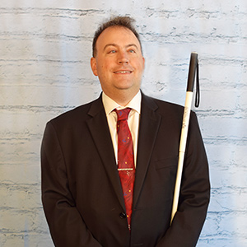

Image: Mark Riccobono
President
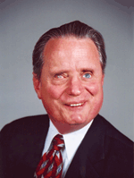
National Federation of the Blind

Image: Marc Maurer
Immediate Past President
National Federation of the Blind

THE MEMBERS OF THE

BOARD OF DIRECTORS AND

THE GREATER BALTIMORE CHAPTER

WELCOME YOU TO THE

53RD ANNUAL CONVENTION OF THE

NATIONAL FEDERATION OF THE BLIND OF MARYLAND

Ronza M Othman, President
National Federation of the Blind of Maryland
15 Charles Plaza, #3002
Baltimore, Maryland 21201

Meleah Jensen, Chairman
Convention Organization and Activities

Ellen Ringlein, President
Greater Baltimore Chapter

Crown Plaza Downtown Baltimore Inner Harbor
105 W. Fayette St., Baltimore, MD 21201
410-347-5707

WELCOME!
Welcome to the 53rd annual convention of the National Federation of the Blind of Maryland being held in Baltimore at the Crown Plaza Baltimore Downtown Inner Harbor. A detailed description of the layout of the hotel can be found later in this agenda. When you check in to the hotel, you will be asked to confirm your departure date. If you decide to leave earlier than the departure date you confirm when you check in, there may be a change fee.
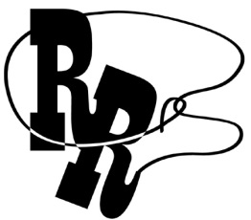
First-Timers Meeting: All first-time convention attendees are cordially invited to attend a First Timers Orientation from 12 to 1 p.m., on Friday, November 8, or directly after the Board Meeting concludes in International Ballroom B. The Ambassadors Committee will walk you through the events that will take place throughout the weekend, explain processes such as registration pickup and banquet exchange, and make sure every first-time convention attendee is matched with a mentor.

INCLUSIVITY, DIVERSITY, AND SOCIAL CONDUCT
As an attendee at our convention, you not only represent yourself, but also represent our greater organization. We want you to enjoy our time together and to make new friends and renew old acquaintances. Although we encourage members to socialize and have fun, the convention also provides a valuable opportunity to come together to continue the work of our organization, to learn about the important initiatives that we are involved with on local and national levels, and to plan our work for the future.

The National Federation of the Blind of Maryland seeks to provide a convention environment in which diverse participants, including members, speakers, exhibitors, staff, and volunteers, may learn, network, and enjoy the company of friends and colleagues in an environment of mutual respect and professionalism. We recognize a shared responsibility to create and uphold that atmosphere for the benefit of all. Some behaviors are therefore specifically prohibited:

- harassment or intimidation based on race, religion, ethnicity, language, gender, sexual orientation, gender identity/expression, disability, physical appearance, or other group identity

- sexual harassment or intimidation, including unwelcome sexual attention, stalking (physical or virtual), or unsolicited physical contact

- public drunkenness and associated behaviors (e.g., belligerence, yelling, hostility, destruction of property)

Participants are expected to abide by these rules and behaviors in all convention venues, including online arenas, social media, and social events. Participants who are asked to stop a behavior that the recipient considers hostile or harassing are expected to comply immediately.
For assistance or to report an incident, please call 504-621-4162. All formal reports will be fully investigated according to the steps outlined in the National Federation of the Blind Code of Conduct. Based on the information found in the investigation, appropriate action will be taken and may involve staff, organization leaders, and legal counsel. Based on the circumstances, hotel security and/or law enforcement may become involved, when appropriate.
We are committed to diversity, equity, and the free expression of ideas. These principles have been delineated in our Code of Conduct found at nfb.org/code-conduct

PREREGISTRATION AND ON-SITE REGISTRATION
Registration activities take place in the Promenade Foyer, which is outside of the International Ballroom, between 2 and 6 p.m., on Friday; 8 and 8:25a.m., and 12 and 12:15 p.m., Saturday; and 8:30 and 8:50 a.m., Sunday. All convention attendees (both local and from out of town) are asked to register. Those who preregistered for convention may pick up their registration packets in the area designated preregistration. Those who did not preregister may go to the area designated registration. Please have your check or cash ready to pay the registration fee of $25 per person; we will pilot a credit card payment process at convention, but as this is a pilot, we cannot guarantee it will work flawlessly. Convention registration is a requirement for door prize eligibility and a number of other convention activities. We condition rates for hotel rooms on proof of registration, including the showing of an NFBMD registration badge, if requested.

FUN WITH FRIENDS CONVENTION CHILD CARE ACTIVITIES
All child care (for children ages 6 weeks to 9 years) will take place in the Pratt Room on the Lower Level. Hours are: Friday 8:30 a.m. to 5:30 p.m.; and Saturday 8:15 a.m. to 5:15 p.m. and 6:30 to 10 p.m. or at conclusion of the banquet, whichever is earlier (lunch and dinner will be provided). Parents, contact Melissa Riccobono for details.

EXHIBIT HALL
The exhibit hall is located in the International Ballroom E and the Promenade Foyer. The exhibit hall will operate on Friday from 11 a.m. to 5 p.m.

SPECIAL ATTENTION ITEMS
- Banquet tickets may be purchased for $45 by cash or check at the on-site registration area. We will pilot a credit card purchasing process, so we cannot guarantee it will work flawlessly. No tickets will be available after 12 p.m. on Saturday. At the banquet ticket exchange table, you may make arrangements to reserve a specific seat for yourself or for a group of up to 10 people. On the evening of the banquet, tickets will be required to enter the ballroom and will be collected at the tables. Tickets may be exchanged for vegetarian or meat meals at the banquet ticket exchange table if done so by 2 p.m. on Saturday.
- Banquet ticket exchange will be located in the Promenade Foyer outside the International Ballroom on Saturday between 1:20 and 2 p.m.
- General Sessions will be held in International Ballroom A through C.
- Boxed Lunches will be resold if not picked up by 12:30 p.m. on Friday. Those interested in boxed lunches on Friday should visit the Promenade Foyer. Those failing to pick up their boxed lunches by 12:30 p.m. on Friday will forfeit them and will not receive a refund.
- Tickets for other meals may be purchased on a first come first serve basis from the registration Table and cost as follows:
  - Picnic and a Play: $20
  - Senior Issues Luncheon: $25
  - Parents Luncheon: $25
- Darlene Price is the chairman of the Door Prize Committee. Please turn in your door prizes to Darlene as soon as possible. You must be registered for the convention and present when your name is called in order to win a door prize. Door prizes will be awarded during the general sessions on Saturday and Sunday and during the convention banquet.
- Mike Bullis is the Chairman of the National Funding Support Committee, which manages our Bake Auction. Please consider bringing baked goods and other food-related items for this auction.
- You are strongly encouraged to bring your NFB membership coins with you to the NFBMD Convention and keep them in your possession at all times. There will be specific incentives, activities, and prizes for those carrying their NFB membership coins.
- We will have a cane walk with individualized cane travel instruction by an NOMC throughout the weekend. To reserve a slot for your child or for yourself, please contact Melissa Riccobono.
- On Sunday, you must check out of your room before 11 a.m.
- If you are leaving the Crown Plaza Baltimore Downtown Inner Harbor by an NFB of Maryland bus, please bring your luggage to the Hopkins Room on the lower level between 7:30 and 9 a.m. Sunday, where it will be tagged and held for storage until noon when buses will be loaded. Please be sure that your luggage is clearly labeled with your name, address, and telephone number.
- The Guide Dog Relief Area is located on the lower level of the hotel outside of the Hopkins Room. Directly to the left of the door is a grassy area. There also is a large cement area just in front of the doors, about 15 feet wide and 30 feet long. There are stairs up to Liberty Street at the perimeter of the cement area, and you can choose to cross the street to visit the dog park on the other side of Liberty Street instead. When exiting the hotel on the lower level, please be sure to prop the door, as it will automatically lock behind you if you do not do so when exiting. Please also remember to make sure the door closes completely behind you when you come back inside the hotel.
- The NFBMD 2019 Convention is located at a free Aira access site. This means those who are existing Aira explorers can use the service without using their own minutes. Those who are interested in trying Aira may do so at no cost. Visit the Aira booth at the exhibit hall for more information.
ORGANIZATION INFORMATION

NATIONAL FEDERATION OF THE BLIND OF MARYLAND

15 Charles Plaza, #3002, Baltimore, MD 21201

443-426-4110; President@nfbmd.org
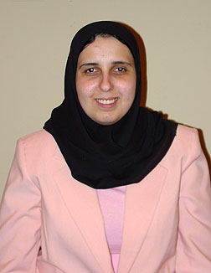
Image: Ronza Othman
President
National Federation of the Blind of Maryland
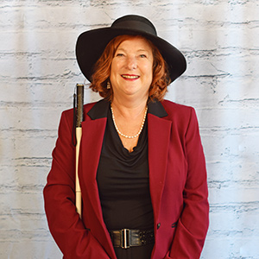
Image: Carla McQuillan
President and National Representative
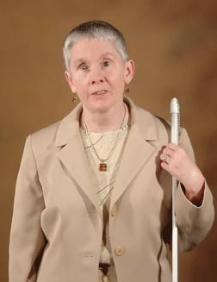
National Federation of the Blind of Oregon
Image: Sharon Maneki
Immediate Past President
National Federation of the Blind of Maryland

Officers:
Ronza Othman, President, Baltimore
Deborah Brown, First Vice President, Rockville
Anil Lewis, Second Vice President, Baltimore
Judy Rasmussen, Secretary, Kensington
Shawn Jacobson, Treasurer, Olney

BOARD OF DIRECTORS:
Michelle Clark, Springdale
Sharon Maneki, Columbia
Maurice Peret, Baltimore
Melissa Riccobono, Baltimore
Melba Taylor, Bowie
Marguerite Woods, Baltimore

OUR CREDO

The National Federation of the Blind knows that blindness is not the characteristic that defines you or your future. Every day we raise the expectations of blind people, because low expectations create obstacles between blind people and our dreams. You can live the life you want; blindness is not what holds you back!

THE NATIONAL FEDERATION OF THE BLIND PLEDGE

I pledge to participate actively in the efforts of the National Federation of the Blind to achieve equality, opportunity, and security for the blind; to support the policies and programs of the federation; and to abide by its constitution.

ABOUT THE NATIONAL FEDERATION OF THE BLIND OF MARYLAND
The National Federation of the Blind of Maryland (NFBMD), an affiliate of the National Federation of the Blind (NFB), is an organization of blind people and their friends. We believe in the full capacity of blind people; we have the power, influence, diversity and determination to help transform our dreams into reality. Our members work together for a brighter tomorrow by raising the expectations for blind people everywhere so that blind persons can live the lives they want.

WHO WE ARE
The National Federation of the Blind of Maryland is a 501c(3) nonprofit made up of blind people of all ages, their families and friends. Our strong local chapters and divisions, and well-trained leaders help newly blind people adjust to vision loss and promote the full participation and integration of blind people in our communities. We bring our collective experiences together to effect change at the state and national level.

WHAT WE DO
- Assist blind persons to acquire the skills of independence
- Help blind persons to develop confidence in themselves through our many service activities
- Teach blind persons the skills of leadership through active participation in conventions, chapter meetings, and civic activities
- Encourage blind seniors to continue their active and meaningful lifestyles
- Prepare blind students for productive tax-paying careers through academic and training scholarships
- Inform people with diabetes about their options for coping with vision loss
- Support parents and friends of blind children with information about the capabilities of the blind
- Protect and promote the civil rights of blind persons through public education and legislative action
- Advocate for policies that eliminate discrimination and guarantee equal access to educational programs and high quality rehabilitation
- Educate the public through seminars, community activities and our publications
VANDA PHARMACEUTICALS INC.

Vanda Pharmaceuticals is dedicated to raising awareness of Non-24-Hour
Sleep-Wake Disorder (Non-24) and supporting the blindness community.
Non-24 is a rare circadian rhythm disorder affecting up to 70% of people
who are totally blind. People living with Non-24 experience excessive daytime sleepiness and nighttime sleeplessness, which leads to impaired social and occupational functioning. This is due to the misalignment between
the internal master body clock and the 24-hour day.

COME VISIT US AT OUR BOOTH
TO LEARN ABOUT NON-24 AND
SIGN UP FOR ADDITIONAL INFORMATION!

NON-24
a circadian rhythm disorder

VISIT us ONLINE AT WWW.NON-24.COM.
CALL A HEALTH EDUCATOR TOLL-FREE AT 1-855-856-2424 - 24 HOURS A DAY, EVERY Day

LIVE THE LIFE YOU WANT

Lyrics copied from October 2015 Presidential Release
Chorus: Live the life you want. Nobody can stop you.
Shoot for the sun and break on through.
So you're blind. You'll be fine. We've got good news!
You can live the life you want. Yes, we know the truth.
Grab a cane, get trained, gotta get movin'.
Make a change in the wage, that's what we're doin'.
Come with me, yeah
Chorus
You and me, NFB, let's dream together.
NFB, you and me, lives on forever.
You will see yeah
Chorus
You can live the life you want. You’ll know the truth.

WE EXTEND PROFUSE THANKS TO THE FOLLOWING CONVENTION SPONSORS:
Brown, Goldstein and Levy LLP, Independence Level Sponsor
Vanda Pharmaceuticals, Independence Level Sponsor
The San Francisco Lighthouse for the Blind and Visually Impaired, Equality Level Sponsor
Elections Systems & Software (ES&S), Opportunity Level Sponsor
Friends of the Maryland State Library for the Blind and Physically Handicapped, Opportunity Level Sponsor
Maryland Technology Assistance Program, Opportunity Level Sponsor
Sprint Accessibility, Opportunity Level Sponsor
Visit Baltimore, Freedom Level Sponsor
3D PhotoWorks, Freedom Level Sponsor

NAVIGATING THE CROWN PLAZA

The Crown Plaza Baltimore Downtown Inner Harbor is located at 105 West Fayette Street, near the southeast corner of Fayette and Liberty. This used to be the Baltimore Downtown Sheraton hotel. The old Sheraton property now has two hotels occupying it, the Crown Plaza and the Radisson. The two hotels share the conference facilities that are called the International Ballroom, Promenade, and Fayette Room, and the Crown Plaza side of the facility houses the Carroll Foyer and lower level conference area. We will only use the sleeping rooms in the Crown Plaza Tower for our convention, but we will use all of the conference facilities at the property. The two hotels also share a restaurant, bar, and other common facilities. However, they each have their own entrances, parking valets, check-in desks, sleeping room towers, fitness facilities, and other amenities. The Radisson entrance also is on Fayette Street, about 150 feet east of the Crown Plaza entrance. Convention attendees should use the Crown Plaza entrance. However, there is a hallway that connects the Radisson and the Crown Plaza, as well as a walkway between the hotels through the restaurant. This description focuses on the Crown Plaza side of the facility, as well as the shared conference space.

We will provide descriptions using cardinal directions, and where possible, also use right and left. Imagine the Crown Plaza main level almost like an upside down capital T with a capital L connecting to the capital T at its bottom left arm. The long arm of the upside-down capital T is the south hallway, and the crossbar of the capital T is the east-west hallway. The International Ballrooms and the Fayette Room are along the east (right) leg of the upside-down capital T. An L-shaped hallway hangs off the left (west) end of the upside-down capital T’s crossbar. The north-south leg of the capital L is used primarily to connect the two conference areas to one another. The east-west leg of the capital L houses the Crown Plaza conference Rooms, Carroll, Poe, and Mencken.

When you first enter the Crown Plaza hotel entrance, you will be facing south. The entrance to the Crown Plaza hotel is on Fayette Street. There is an automatic door that leads you into a vestibule. Immediately on your left (east) is the entrance to the shared restaurant, Harbor Sports Bar and Grill. You come across the entrance to this restaurant even before you enter the second doors to the Crown Plaza hotel, and so it is really in the vestibule rather than in the hotel itself.

If you walk into the Crown Plaza hotel main entrance and find yourself in the vestibule, you will find the second set of doors to the hotel on your right. Once you enter those doors, you are facing west, and the restaurant is behind you and Fayette street is on your right. The check-in desks are on your right along the north wall. There are two of them with a space between them. At the west end of this part of the lobby and across from (south of) the second check-in desk is an unstaffed snack bar.

If you orient yourself so that your back is to the first check-in desk, you are at the top of the upside-down capital T; you enter a hallway that goes north and south, which we will call the south hallway. As you walk south along the south hallway, on your left you will pass a common area containing various desks and chairs for use by hotel guests, as well as an ATM. On your right is another common area with carpeting containing sofas and chairs with charging ports in the conversation areas. At the southern end of this carpeted seating area is a long tall table with high stools, where you can recharge your electronic devices. Past this seating area on the right is the accessible entrance to the hotel lobby bar. If you wish to visit the bar, look for a ramp to go up to the bar off towards your right. If you continue south past the lobby bar, you reach the apex of the upside-down capital T, which is an east-west hallway. The south hallway comes to a dead end here.

If you enter the east-west hallway (the crossbar of the upside-down capital T) by turning left (east), the elevator banks will be on your right (south) just before you encounter carpeting. If you turn into the elevator bank hallway, two elevators will be on your right (on the west wall) and one to the left (on the east wall). These elevators will take you up to the sleeping rooms and down to the lower level conference facilities.

If you continue east along the east-west hallway (the crossbar of the capital T) past the elevator lobby, you come to a carpeted area followed by a strip of tile floor that is about five feet wide, and beyond it, more carpeting. Once you reach the second carpeted area, you are in the Promenade Foyer. Registration will be in the Promenade Foyer throughout the weekend. On your right (south) are the International Ballrooms, which are comprised of ballrooms A through F. You first encounter the doors for International Ballroom A. The doors to Ballroom A will be used for general session. Ballroom A also will be one of the workshop rooms on Friday. Ballrooms B and C are south of ballroom A and all three can be combined together to make one big room, Ballroom ABC. Our general session will be held in Ballroom ABC, and we will have workshops on Friday in Ballrooms A, B, and C as separate meeting rooms. There is no direct access to ballrooms B and C from the Promenade hallway. If the International ballroom is subdivided into A, B, and C, then dividing walls are also setup to create a small access hallway which runs along the east (left if you put the doors of Ballroom A in front of you) end of Ballrooms A, B, and C. To reach this hallway, look for the next set of doors past ballroom A, which are labeled International Ballroom (no letters), and turn right (south). If you keep walking east along the Promenade Foyer beyond International Ballroom A, the next ballroom you encounter is International Ballroom F. Past Ballroom F is another set of doors that leads into Ballroom D. Ballroom D has a raised fixed stage in it that we will not use.

Across from International Ballroom A on the north side of the Promenade hallway are restrooms (ladies’ on the left and men's on the right). Past the restrooms, across from Ballroom F is a hallway that branches off to the left (north) and leads to the Radisson Hotel. We will not use any facilities in the Radisson. The Promenade Foyer will come to a dead end at the east end at some steps leading up to Ballroom E and the Fayette Room. To avoid the steps leading down to the hotel business office, from this upper level, at the top of the steps continue straight (east) all the way to the east wall, before turning right (south) to find the entrance to Ballroom E. At the top of the steps continue straight (east) all the way to the east wall, before turning left (north) to find the entrance to the Fayette Room. The Fayette Room has glass walls. Directly to the right (south) of the steps leading up to Ballroom E and the Fayette Room is a wheelchair lift. Your cane can easily miss this obstacle, so to be forewarned is to be forearmed.

If at the apex of the upside-down capital T, you turn right (west), another entrance to the lobby bar is to your right and there is a set of steps that leads up to the bar from this side. The hallway will come to a dead end past the bar, and you would enter the capital L hallway if you turn left (south).

Along the east arm of the capital L hallway, there is a spiral staircase that leads to the lower floor of the hotel. Of course, you can reach the lower floor via the elevators as well. Past the area where the spiral staircase is, the L-shaped hallway continues south and comes to a dead end at its apex, another hallway that leads left (east). There are other arms that branch off of the capital L, but they are not relevant to our needs, and if you shoreline along the wall, you will reach the apex of the capital L. The entrance to the Carroll Room is on the left (north) side of this short east-west hallway. On the right (south) side of the hallway is the Poe Room followed by the Mencken Room. The east hallway (capital L) comes to a dead end at a service area and you'll have to retrace your steps to get to other parts of the hotel. The parents and teachers seminars, student division, and merchants division meetings will be in this hallway on Friday.

There are more meeting rooms we will use in the lower lobby. The lower level conference space is like a capital H with the elevator hallway as the crossbar connecting the two legs of the capital H. To reach the area where we will have meetings and seminars, turn right from the set of two elevators or left from the single elevator towards the leg of the capital H with more meeting rooms. Pratt A and B are along the leg of the H, and Douglass is at one end of the leg while Peale is at the other. If you are facing the Pratt room, the Peale room is to your right (west) and the Douglass room is to your left (east). Pratt is where we will have childcare.

To reach the area where teens and tweens will meet, and where luggage drop-off will be, turn left from the set of two elevators or right from the single elevator towards the leg of the capital H where there is only one meeting room and the spiral staircase as the major landmark. The Hopkins Room is along the leg of the capital H. Restrooms are at the top of that same leg of the capital H. This area also holds the spiral staircase which leads to the upper floor. To find the steps safely, go all the way to the west end by the entrance to Hopkins and turn left (south).

To find the guide dog relief area, orient yourself so the side with the two elevators is behind you and turn left (until you meet a hallway). Turn left again and walk straight until you meet a set of double doors to the outside of the hotel.

The hallways on the guest room floors of the Crown Plaza are quite short. Each floor will have rooms 20 through 35. The lower numbered rooms are in the Radisson tower. Imagine each floor is like a capital H with the elevator bank as the crossbar of the H. If you put the side with the two elevators behind you and go clockwise starting with the bottom left leg of the H, you will encounter rooms 20 to 23 (northwest side), rooms 24 to 27 (northeast side) rooms 28 to 31 (southeast side), and rooms 32 to 35 (southwest side).

CHAPTERS AND DIVISIONS OF
THE NATIONAL FEDERATION OF THE BLIND OF MARYLAND

At Large Chapter
Marguerite Woods, President, 443-271-1668, mwoods719@gmail.com
Monthly meetings third Tuesday at 7:30 p.m., via phone:
(605) 313-4818, access code 720125

Baltimore County Chapter
Ruth Sager, President, 410-602-9030, rsager78@gmail.com
Monthly meetings fourth Wednesday in Pikesville

Central Maryland Chapter
Darlene Price, President, 410-209-7713, chicagirl3@verizon.net
Monthly meetings first Tuesday in Columbia

Eastern Shore Chapter
Heather Guy, President, 410-430-8954, hguy403@comcast.net
Monthly meetings second Saturday in Salisbury

Greater Baltimore Chapter
Ellen Ringlein, President, 443-516-7855, Eringlein@nfb.org
Monthly meetings third Saturday in Baltimore

Greater Carroll County Chapter
Brian Keseling, President, 410-855-5605, bkmaverick@gmail.com
Monthly meetings second Saturday in Westminster

Greater Cumberland Chapter
Jean Faulkner, President, 301-729-8942
Monthly meetings third Wednesday in Cumberland

Maryland Association of Blind Students
Ellana Crew, President, 443-758-7211, eemcrew@gmail.com
Periodic meetings throughout the year

Maryland Association of Blind Merchants
Melba Taylor, President, 240-381-1637, m.taylor@encoreassoc.com
Periodic meetings throughout the year

Maryland Parents of Blind Children
Melissa Riccobono, President, 443-708-3663, MelissaARiccobono@gmail.com
Periodic meetings throughout the year

National Harbor Chapter
Michelle Clark, President, 301-583-8585, mcikeyc@aol.com
Monthly meetings fourth Saturday in Suitland

Senior Issues Division
Ruth Sager, President, 410-602-9030, rsager78@gmail.com.
Periodic meetings throughout the year

Sligo Creek Chapter
Debbie Brown, President, 301-881-1892, Deborahb14@verizon.net
Monthly meetings second Saturday primarily in Silver Spring

TLC Chapter
Meleah Jensen, President, 504-621-4162, MeleahHeather@gmail.com
Meetings third Thursday in Towson

The San Francisco LightHouse for the Blind and Visually Impaired
2018 Dr. Jacob Bolotin Award recipient brings you:
TMAP: on-demand tactile street maps!
TMAPs depict the area around a user-specified address or intersection. Streets, pedestrian paths, and buildings are shown with raised lines, easily followed with the fingertips. Braille and large print labels indicate street names and other critical information like cardinal directions and scale.
Place your TMAP order at 1-888-400-8933
Mention promo code TMAP NFB through November and get a 20% discount! (Regular price $25)

COMMITTEES OF THE
NATIONAL FEDERATION OF THE BLIND OF MARYLAND
If you’re interested in being appointed to a particular committee, notify the NFBMD president at president@nfbmd.org or 443-426-4110.

Advocacy Committee
Sharon Maneki, Chairman

Ambassadors Committee
Judy Rasmussen, Chairman

Audit Committee
Barry Hond, Chairman

BELL Committee
Melissa Riccobono, Chairman

Braille Spectator Committee
Ronza Othman and Sharon Maneki, Editors

Deaf-Blind and Hearing Loss Issues Committee
Janice Toothman, Chairman

Development and Fundraising Committee
Anil Lewis and Shawn Jacobson, Co-chairmen

Guide Dog Issues Committee
Ashley Alvey and Janice Toothman, Co-chairmen

Legislation Committee
Sharon Maneki, Chairman

Membership Committee
Dezman Jackson, Chairman

PAC Plan Committee
John G. Paré Jr., Chairman

Public Relations Committee
Chris Danielsen, Chairman

Resolutions Committee
Jesse Hartle, Chairman

Scholarship Committee
Mildred Rivera, Chairman

Sharon Maneki Youth Empowerment Grant Committee
Sharon Maneki, Chairman

Social Media Committee
Karen Anderson, Chairman

Website and Technology Committee
Graham Mehl, Chairman

Youth Activity Committee
Melissa Lomax, Chairman

Convention-Related Committees

Anna Freysz Cable Award Committee
Debbie Brown, Chairman

Convention Child Care Committee
Christine Day, Chairman

Convention Hospitality Committee
Ellen Ringlein, Chairman

Convention Organization and Activities
Meleah Jensen, Chairman

Convention Registration Committee
Marie Marucci, Chairman

Distinguished Educator of Blind Children Award Committee
Sandy Bishop, Chairman

Door Prize Committee
Darlene Price, Chairman

Gold Cup Crab Race Committee
Rose Warner, Chairman

Jennifer Baker Award Committee
Susan Baker, Chairman

Kenneth Jernigan Award Committee
Dr. Marc Maurer, Chairman

National Funding Support Auction Committee
Michael Bullis, Chairman

Nominating Committee
Ellen Ringlein, Chairman

Leaving A Legacy
Dream Makers Circle
You can help build a future of opportunity for the blind by becoming a member of our Dream Makers Circle. It is easier than you think. Just visit your bank and convert an account to a P.O.D. (payable on death) bank account which is payable after your passing to the National Federation of the Blind or the National Federation of the Blind of Maryland. Your legacy gift to the National Federation of the Blind or the National Federation of the Blind of Maryland can be made in the form of a will or living trust, an income generating gift, or by naming us as the beneficiary of a retirement plan, IRA, pension, or a life insurance policy. You can designate a specific amount, a percentage, or list NFB as one of several beneficiaries. For additional information, please contact Patti Chang at 410-659-9314, ext. 2422 or at pchang@nfb.org.

BROWN, GOLDSTEIN, and LEVY
CONGRATULATIONS ON 50+ YEARS OF
BREAKING
BARRIERS
120 E. Baltimore Street, Suite 1700, Baltimore MD 21202
tel. 410.962.1030 • fax 410.385.0869 • www.browngold.com

STAY CONNECTED AND INFORMED:

Follow the National Federation of the Blind of Maryland on Twitter:
twitter.com/NFBMD

Friend the National Federation of the Blind of Maryland on Facebook: facebook.com/nationalfederationoftheblindofmaryland

Stay connected with your fellow Maryland Federationists by joining our state email listserv. This list allows you to receive affiliate and national announcements, and also to start and participate in discussions regarding blindness and blindness issues. To sign up visit nfbnet.org, click on “join or drop NFB mailing lists,” and activate “NFBMD” link, and follow the instructions. Many of our local chapters now also have a listserv. Talk to your chapter president to learn how to sign up so you don’t miss important information about chapter news and events.

Visit our website at nfbmd.org. Check out our blog for the President’s Messages. We welcome blog posts from all of our members. Be sure to check out the Blindness Resources link, and the Know Your Rights link to keep up to date on important information. Be sure to download and print “About NFBMD,” in the “About Us” tab on nfbmd.org, for use at chapter outreach events.

BRAILLE SPECTATOR
The Braille Spectator is published for members of the National Federation of the Blind of Maryland and others who share an interest in the work of this organization. The Braille Spectator can be read on the web at nfbmd.org/newsletter or can be listened to on the local channel of NFB-Newsline.
STRIVE
Lyrics by Barbara Elliott
Sometimes people tell me blind people should be quiet and sit down
But I say "No!" I say "No!" I say "No."
They contend that I should be content to let others lead me around,
But I say "No!" I say "No!" I say "No."
Everybody needs somebody to help sometimes, but I'm in charge of me,
CHORUS: I've gotta strive, strive, strive a little farther,
Reach, reach, reach a little longer,
Work, work, work a little harder,
Hope, hope, hope a little stronger.
Watch me, watch me, watch me.
Nothin's gonna stop me, stop me, stop me.
I'm spreading my wings, soaring on a dream,
I can do anything!
I gotta be brave even when I'm afraid to do hard things.
I'll tell myself "Go!" I'll just go, I will go.
I'm not a fool; I need training and tools to live out my dreams.
So I'll say "Go!" I'll just go, I will go.
I'm not a passenger in my life. I'm gonna take control and drive.
Chorus

Live the Life You Want with the KNFB Reader

Fast, Accurate, Efficient

With the KNFB Reader, you can read such printed items as credit card receipts, packaging labels, mail, product information, computer screens, and of course books and documents. Take a photo and the app reads the text aloud or publishes it in Braille if you have refreshable Braille display.
Learn more and purchase KNFB Reader for iPhone, Android, and Windows 10 devices at http://www.knfbreader.com

EXPANDING OUR PROMINANCE IN MARYLAND

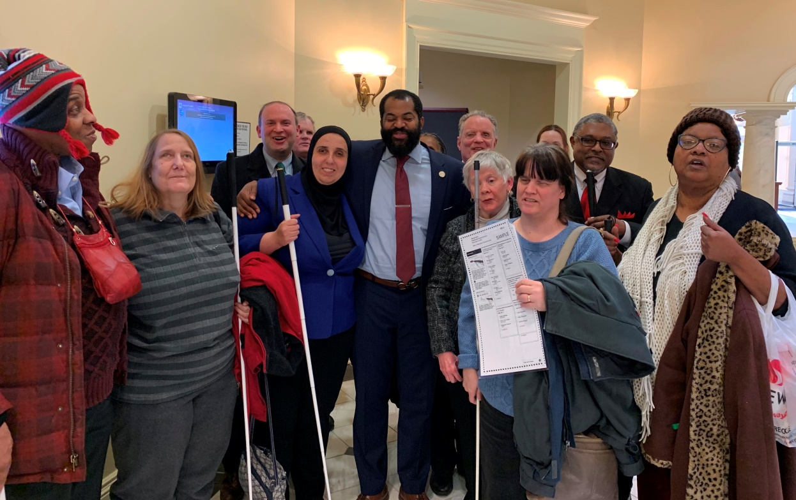
Image: NFBMD engaged in legislative advocacy in Annapolis with Delegate Mosby fighting for desegregated voting based on disability
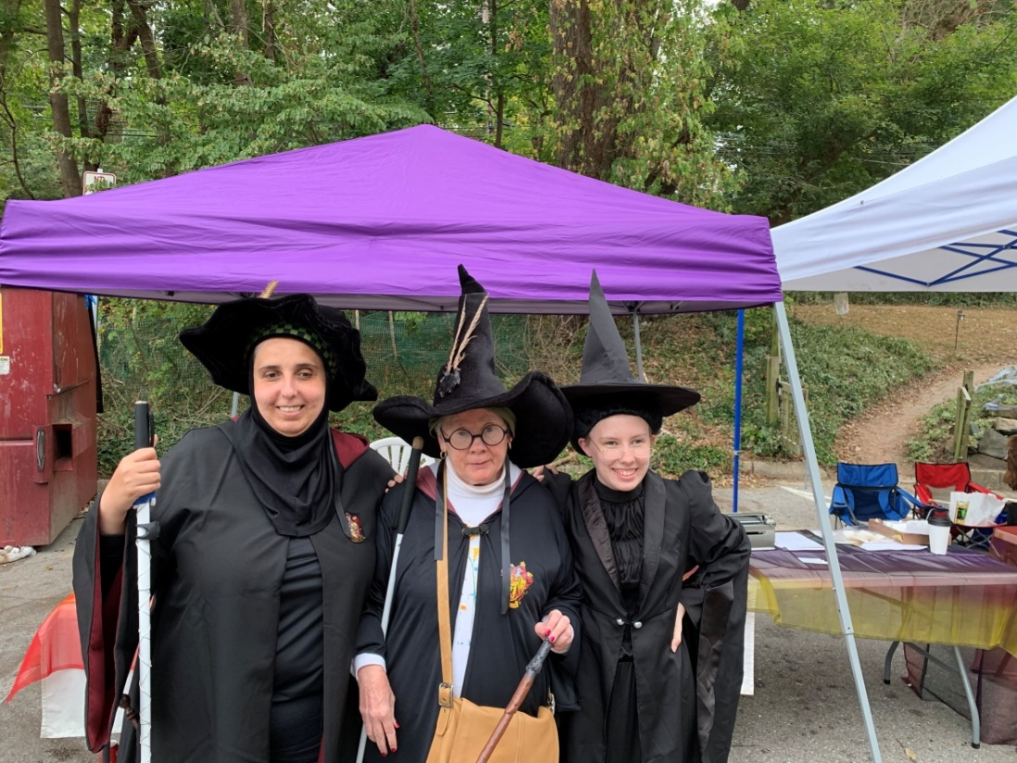
Image: Participants dressed in costume for the NFB Meet the Blind Month Wizarding Weekend on Main in Old Ellicott City

2019 NFB BELL GLENN DALE

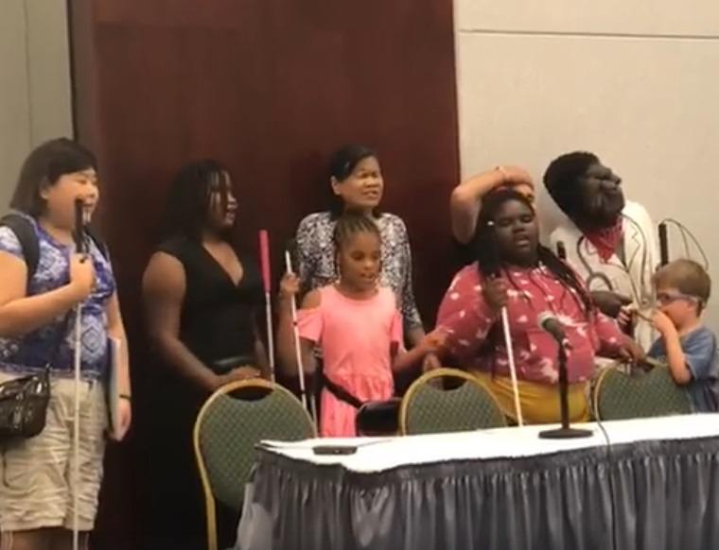
Image: NFB BELL Academy participants singing our original BELL song

2019 NFB BELL BALTIMORE

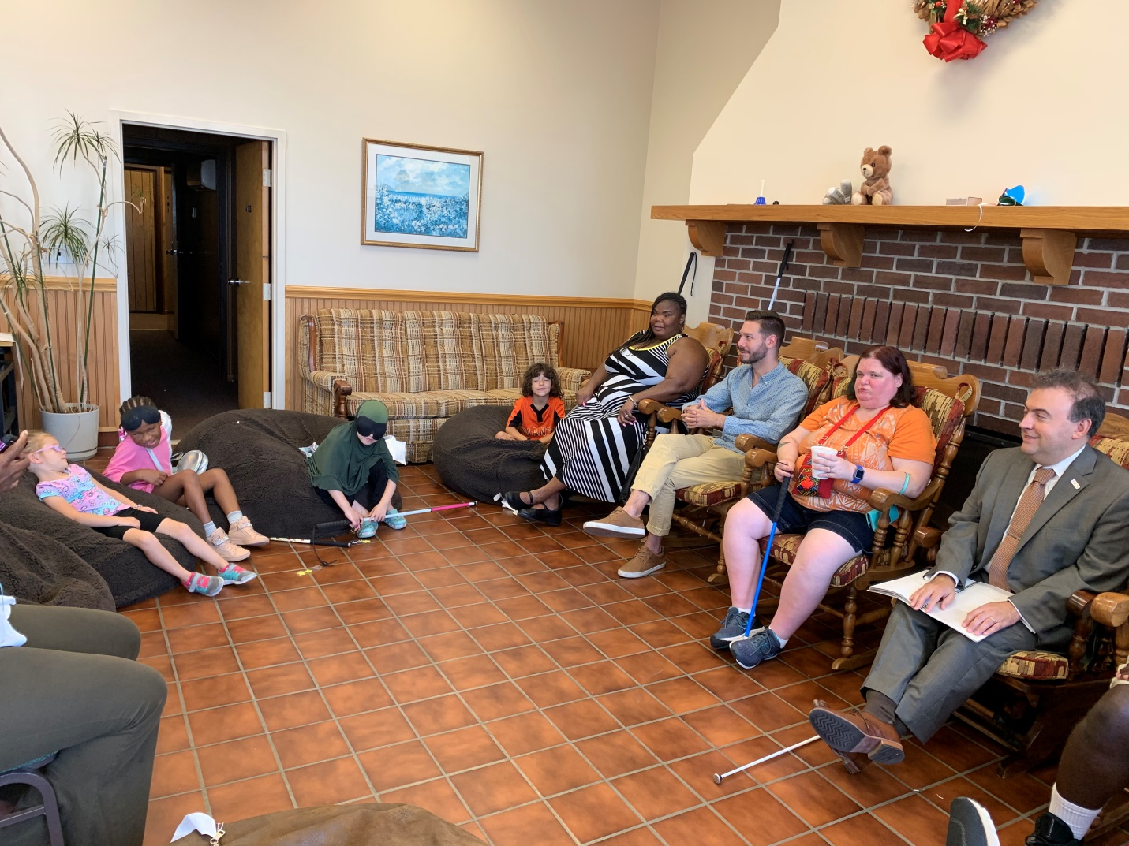
Image: President Riccobono reading with NFB BELL Academy participants

2019 NFB BELL SALISBURY

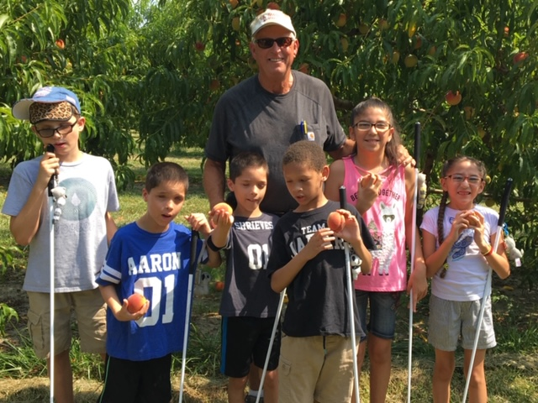
Image: BELL participants picked peaches and later assembled peach baskets for blind seniors

CONVENTION AGENDA

FRIDAY, NOVEMBER 8
8 a.m. - 5:30 p.m.—FUN WITH FRIENDS CHILDCARE
Pratt Room
Anna Givens, Childcare and Youth Coordinator; Arlington, Virginia

8 a.m. - 5 p.m.—ANNUAL CONFERENCE FOR PARENTS AND TEACHERS OF BLIND CHILDREN: MARYLAND PARENTS OF BLIND CHILDREN
Carroll Room
What are the skills and tools blind students need in school and to live the lives they want? How do you make sure school services are appropriately addressing their needs? What can you do to support them at home? Learn about the benefits of summer programs and how to help your child with other blindness skills. These are only some of the topics to be discussed at this seminar. Featured speakers at this seminar will be Jackie Anderson, a long time teacher of blind students, blind parent, and originator of the concept for the NFB BELL Academy and Carla McQuillan, the owner operator of a Montessori preschool program and a blind parent. Melissa Riccobono, President, Maryland Parents of Blind Children Division; Baltimore, Maryland

8 - 8:45 a.m.—REGISTRATION
See Parent Agenda for more information.

9 a.m. - 5 p.m.—TEEN/TWEEN ACTIVITIES
Hopkins Room
Anna Givens, Coordinator, Child and Youth Coordinator; Arlington, Virginia

9:30 - 10:30 a.m.—RESOLUTIONS COMMITTEE MEETING
International Ballroom A
Everyone is encouraged to attend!
Jesse Hartle, Chairman; Lutherville, Maryland

9:30 a.m. - 6 p.m.—NFBMD AUDIO QUILT PROJECT
Fayette Room
We are bringing our theme of “Celebrating Our Story, Defining Our Future” to life by asking Federationists to visit the NFBMD Recording Studio to record a message that will be woven into an audio quilt. Please drop into the studio when you have a few moments. Please be prepared to provide the following information:
- Your name;
- year you joined the federation;
- name of person who brought you into the federation; and
- the one activity, program, or event that the federation did since you joined that has most impacted you (This must be one sentence or less).
Steve Sawczyn, Chief Audio Quilter and Sound Engineer, Minneapolis, Minnesota

10:30 a.m. - 12 p.m.—NFBMD BOARD OF DIRECTORS MEETING (Open to All)
International Ballroom D and F

10:30 a.m. - 2 p.m.—NATIONAL CERTIFICATION IN UNIFIED ENGLISH BRAILLE (NCEUB) EXAMINATION (Advanced registration is required)
Peale Room
This nationally recognized exam will be a requirement for all TVIs seeking certification in the state of Maryland starting October 1, 2020. More information, as well as registration forms are available at: sites.google.com/view/tviportalmaryland/ncueb-testing. Deadline to register is October 25, 2019. Conchita Hernandez, Proctor and Maryland Statewide Low Incidence Specialist (Blind and Low Vision), Maryland Department of Education; Washington, DC

11 a.m. - 5 p.m.—EXHIBITS
International Ballroom E and Promenade Foyer
Check out the latest offerings from a variety of companies and organizations that provide technology and services for the blind. Anil Lewis, Sponsorship and Exhibits Coordinator and Second Vice President, National Federation of the Blind of Maryland; Baltimore, Maryland

11:30 a.m.—BOXED LUNCH DISTRIBUTION
Promenade Foyer: Those not attending Parent and Teacher Conference
Carroll Foyer: Those attending Parent and Teacher Conference
*You paid for a boxed lunch at pre-registration.

12 - 1 p.m.—FIRST TIME CONVENTION ATTENDEES ORIENTATION
International D
This meeting is for first-time attendees to the National Federation of the Blind of Maryland Convention. Come to get oriented to the activities that will take place throughout the weekend. Get all of your questions answered.
Judy Rasmussen, Ambassador Committee Chairman and Secretary, National Federation of the Blind of Maryland; Kensington, Maryland

1 p.m.—NFBMD TOURS DEPART
International B
Those who are going on the NFBMD Tours will meet and depart from this room. All participants must pay $10 per person prior to being permitted to participate in a tour.
Tour A: Ravens Stadium at M&T Field
Tour B: The Every Man Theater – Behind the Scenes
Ellen Ringlein, Travel Agent and President, Greater Baltimore Chapter; Baltimore, Maryland

1 - 2:30 p.m.—NFBMD TOWN HALL
International Ballroom DF
Come discuss what you feel would make our affiliate more effective. How can we better advance our mission for the blind of Maryland and the nation? What programs work, and what programs do not? This gathering will provide an opportunity for open discussion about how to shape the National Federation of the Blind of Maryland moving forward. Mark Riccobono, Facilitator; President, National Federation of the Blind; Baltimore, Maryland

1 - 2:30 p.m.—STORY SOURCE: WHERE TO GET THEM AND HOW TO PLAY THEM!
International Ballroom A
There are many ways to find excellent books to read. This workshop examines the various sources for finding books and stories for the blind and with what blindness related technologies those services are compatible. Sharon Maneki, Coordinator; President, Friends of the Maryland Library for the Blind and Physically Handicapped and Board Member, National Federation of the Blind of Maryland; Columbia, Maryland

2 - 6 p.m.—CONVENTION REGISTRATION AND PACKET PICKUP
Promenade foyer

2:30 - 4 p.m.—OUR STORY THROUGH ORAL HISTORY
International Ballroom A
Our individual and collective history is a rich and varied one. Come learn about how to capture our stories through oral history. Lou Ann Blake, /Deputy Executive Director of Blindness Initiatives, National Federation of the Blind; Baltimore, Maryland

2:30 - 4 p.m.—JOB HUNTING: TELLING OUR STORIES IN RESUMES AND THROUGH INTERVIEWS
International Ballroom C
Our resumes tell prospective employers our work and academic stories. Ever wonder how to make your resume stand out? Ever wonder what interview techniques would make you more memorable so that those prospective employers would want to hire you? Ever wonder how to talk about your blindness, or whether or not to even talk about it at all? Then this is the workshop for you. Eileen Rivera Ley, Treasurer, TLC Chapter; Baltimore, Maryland; Millie Rivera, NFBMD Scholarship Chairman, Halethorpe, Maryland; Dr. Sandra Rivera, Economist, U.S. International Trade Commission; Washington, DC

4 - 6 p.m.—LET’S PLAY BINGO AND WIN PRIZES!
International Ballroom DF
Sponsored by Blind Industries and Services of Maryland. Everyone is invited to attend!, Heather Guy, Bingo Coordinator, BISM Staff Member, and President, Eastern Shore Chapter; Salisbury, Maryland

4 - 5 p.m.—DEAF-BLIND AND HEARING LOSS ISSUES COMMITTEE MEETING
Douglass Room
Share strategies and ideas to maintain independence. Anyone interested is invited to attend. Janice Toothman, Chairman; Bowie, Maryland
Agenda:
- Tips for using AIRA with hearing and vision loss
- How to Advocate for services at your Individualized Education Plan and beyond
- Low cost ways to increase enjoyment of everyday activities
- Exercises to improve your balance and remain active

Support the National Deaf-Blind Division by purchasing one of our signature Braille alphabet T-shirts with the NFB logo on the front. If you missed the National convention in Las Vegas, here is your opportunity to buy a T-Shirt in the following sizes/colors:
Red: Large (2)
Navy: Youth Medium (1), Adult X-large (1)
Orange: Medium (1), Large (2)
Pink: Small (1)
Grey: X-Large (2)
Green: Medium (1)
T-Shirts cost $17, which can be made by cash or check at the meeting on Friday in the Douglas room or contacting Janice Toothman at 667-231-9164 TEXT is Preferred and arranging to meet during the other times of the Convention.

4 - 6:30 p.m.—STUDENT WORKSHOP
Poe Room
Come learn about matters of interest to students including how to self-advocate in school, with potential employers, and in the world. Learn what resources are available for students. Ellana Crew, President, Maryland Association of Blind Students; Baltimore, Maryland

5 - 6 p.m.—PROTECTING THE RIGHTS OF GUIDE DOG USERS
Douglass Room
Share strategies and ideas on how to ensure that the rights of guide dog users are protected. Ashley Alvey, Co-chairman; Baltimore Maryland; Janice Toothman, Co-chairman; Bowie, Maryland

5 - 6 p.m.—BLIND PARENTS MEETING
Peale Room
Share tips and tricks on how to parent using non-visual techniques. Network with other blind parents and caregivers. Melissa Riccobono, Chairman; Baltimore Maryland

5 - 9 p.m.—MARYLAND ASSOCIATION OF BLIND MERCHANTS SYMPOSIUM AND NETWORKING MIXER
Mencken Room
Come learn about matters of interest to blind merchants and those in the Business Enterprise Program.
5 - 7 p.m.—Symposium
7 - 9 p.m.—Networking Mixer
Melba Taylor, President

5:30 - 8 p.m.—PARENT AND FAMILIES NETWORKING DINNER
Carroll Room
Participants of the Parent and Teacher Seminar and those with school-aged children are invited to a casual pizza party. This is an opportunity for families to chat and get to know one another. Melissa Riccobono, President, Maryland Parents of Blind Children; Baltimore, Maryland

6:30 - 8:30 p.m.—PICNIC AND A PLAY
International Ballroom ABC
The Braille is Beautiful players will perform Rudolph the Nasally Impaired Reindeer, an original play written by Debbie Brown.
Debbie Brown, Play Author and Director; First Vice President, National Federation of the Blind of Maryland; Rockville, Maryland

6:30 p.m.—NFB BELL ACADEMY REUNION
Peale Room

8:30 - 11:30 p.m.—NFBMD FAMILY GAMES NIGHT
International Ballroom DF
This gameshow style evening promises to be fun for all ages. Enjoy snacks and fellowship. Gameshow Host: Melissa Riccobono, Board Member, National Federation of the Blind of Maryland; Baltimore, Maryland

SATURDAY, NOVEMBER 9
7 - 8:15 a.m.—IEP WORKSHOP
Carroll Room
Learn about the new requirements that the State of Maryland has added to IEPs from an expert. Continental breakfast will be available. Conchita Hernandez, Maryland Statewide Low Incidence Specialist (Blind and Low Vision), Maryland State Department of Education; Washington, DC

7 - 8:15 a.m.—MARYLAND ASSOCIATION OF BLIND STUDENTS ANNUAL MEETING
Poe Room
The Maryland Association of Blind Students will hold its annual business meeting, including planning future workshops and events and holding elections. Continental breakfast will be available. Ellana Crew, President; Baltimore, Maryland

7 - 8:15 a.m.—AT-LARGE CHAPTER MEETING
Mencken Room
The At-Large Chapter will meet face-to-face. Continental breakfast will be available. Marguerite Woods, President; Baltimore, Maryland

8 - 8:25 a.m.—CONVENTION REGISTRATION AND PACKET PICKUP
Promenade foyer

8 a.m. - 5:15 p.m.—FUN WITH FRIENDS CHILDCARE
Pratt Room
Anna Givens, Coordinator; Arlington, Virginia

8 a.m. - 3 p.m.—NFBMD AUDIO QUILT PROJECT
Fayette Room
We are bringing our theme of “Celebrating Our Story, Defining Our Future” to life by asking Federationists to visit the NFBMD Recording Studio to record a message that will be woven into an audio quilt. Please drop into the studio when you have a few moments. Please be prepared to provide the following information:
- Your name;
- year you joined the Federation;
- name of person who brought you into the federation; and
- the one activity, program, or event that the federation did since you joined that has most impacted you (This must be one sentence or less).
Steve Sawczyn, Chief Audio Quilter and Sound Engineer; Minneapolis, Minnesota

8:30 a.m. - 5 p.m.—TEEN/TWEEN ACTIVITIES
Hopkins Room
Anna Givens, Child and Youth Coordinator; Arlington, Virginia

SATURDAY MORNING SESSION

All general sessions will be held in International Ballroom ABC

8:30 a.m.—CALL TO ORDER, OPENING CEREMONIES, AND INVOCATION

8:45 a.m.—GET MEMBORIZED: NFB MEMBERSHIP CEREMONY
Dezman Jackson, Membership Chair, National Federation of the Blind of Maryland; Baltimore, Maryland

9:05 a.m.—BALTIMORE CITY WELCOME
Bernard C. “Jack” Young, Mayor, City of Baltimore; Baltimore, Maryland

9:15 a.m.—GREETINGS FROM THE NATIONAL PRESIDENT
Mark Riccobono, President, National Federation of the Blind; Baltimore, Maryland
ENSURING OUR FUTURE BY SUPPORTING OUR NATIONAL FUNDS: WHITE CANE, SUN, KENNETH JERNIGAN, AND JACOBUS TENBROEK
Dr. Marc Maurer, Immediate Past President, National Federation of the Blind; Catonsville, Maryland
GET ON THE PAC PLAN
John Paré, Executive Director of Advocacy and Policy, National Federation of the Blind, Maryland PAC Plan Chairman; Baltimore, Maryland
GOLD CUP CRAB RACE
Rose Warner, Ticket Agent; Baltimore, Maryland

9:40 a.m.—A GLIMPSE INTO OUR NATIONAL STORY: A REPORT FROM OUR NATIONAL OFFICE
Carla McQuillan, Member, Board of Directors, National Federation of the Blind; President, NFB of Oregon, Portland, Oregon

10:10 a.m.—DEFINING OUR FUTURE: TRAINING, REHABILITATION, AND SERVING THE PUBLIC
Fred Puente, President, Blind Industries and Services of Maryland; Salisbury, Maryland

10:20 a.m.—TRANSPORTATION IN MARYLAND AND BEYOND: OUR FIGHT TO MAINTAIN OUR RIGHT TO TRAVEL INDEPENDENTLY
Kevin Quinn, Administrator, Maryland Transit Administration; Baltimore, Maryland
Maurice Peret, Board Member, National Federation of the Blind of Maryland; Baltimore, Maryland
Sara Gayton, Shared Space Coordinator, National Federation of the Blind of the UK; London, England

10:50 a.m.—QUESTIONS AND DISCUSSION

11 a.m.—OUR STORY: THE HISTORY OF THE MARYLAND AFFILIATE
Dr. Marc Maurer, Immediate Past President, National Federation of the Blind; Catonsville, Maryland

11:10 a.m.—FEDERAL WELCOME
Senator Benjamin Cardin, United States Senate; Maryland

11:25 a.m.—THE STORY OF US: LEADERSHIP GROUNDED IN A SHARED FUTURE
Mark Riccobono, President, National Federation of the Blind; Baltimore, Maryland

11:35 a.m.—OUR STORY, OUR DISTRICT
Senator Bill Ferguson, District 46, Maryland State Senate; Annapolis, Maryland

11:50 a.m.—QUESTIONS AND DISCUSSION

NOON—ADJOURN

12 - 12:15 p.m.—CONVENTION REGISTRATION AND PACKET PICK-UP
Promenade Foyer

12 - 1:45 p.m.—LUNCHEON: THE EDUCATION OF BLIND AND LOW VISION STUDENTS
Carroll Room
For parents, teachers of the blind, and those interested in matters concerning blind students. Sponsored by Brown, Goldstein and Levy. Melissa Riccobono, President, Maryland Parents of Blind Children’s Division, National Federation of the Blind of Maryland; Baltimore, Maryland

12 - 1:45 p.m.—LUNCHEON: RECLAIMING INDEPENDENCE AFTER VISION LOSS
International Ballroom DF
For seniors and others facing vision loss. Sponsored by Vanda Pharmaceuticals. Ruth Sager, President, Maryland Senior Issues Division, National Federation of the Blind of Maryland; Baltimore, Maryland

1:20 - 2 p.m.—BANQUET TICKET EXCHANGE
Promenade Foyer

SATURDAY AFTERNOON SESSION
2 p.m.—CALL TO ORDER

2:05 p.m.—CELEBRATING OUR STORIES, DEFINING OUR FUTURE
Ronza Othman, President, National Federation of the Blind of Maryland; Baltimore, Maryland

2:40 p.m.—DELEGATE WELCOME
Delegate Robbyn Lewis, District 46, Maryland House of Delegates; Baltimore, Maryland

2:50 p.m.—PARTNERING WITH COMMUNITY ORGANIZATIONS FOR A BETTER FUTURE
Tony Stevens, Executive Director, Downtown Baltimore Family Alliance; Baltimore, Maryland

3 p.m.—ENCYCLOPEDIA OF SERVICES FOR THE BLIND
A statewide approach for inclusion and equal access for the blind
Carol Beatty, Secretary, Maryland Department of Disability; Baltimore, Maryland
Vocational Rehabilitation Services for Tomorrow
Toni March, Director, Office of Blindness and Vision Services, Maryland Division of Rehabilitation Services (DORS); Baltimore, Maryland
One Team
W. Robert Hair, Superintendent, Maryland School for the Blind; Baltimore, Maryland
Our Library, Our Story, Our Future
John Owen, Director, Maryland State Library for the Blind and Physically Handicapped; Baltimore, Maryland

3:40 p.m.—QUESTIONS AND DISCUSSION

3:50 p.m.—PAYING IT FORWARD: CAREER MENTORING
Anil Lewis, Executive Director of Blindness Initiatives, National Federation of the Blind; Baltimore, Maryland

4 p.m.—WRITING OUR OWN HAPPY ENDING: DESEGREGATING VOTING BASED ON DISABILITY IN MARYLAND
Moderator: Sharon Maneki, Director of Legislation and Advocacy, National Federation of the Blind of Maryland; Columbia, Maryland
Senator Clarence Lam, Maryland State Senate; Annapolis, Maryland
Delegate Nick Mosby, Maryland House of Delegates; Baltimore, Maryland
Lou Ann Blake, Deputy Executive Director of Blindness Initiatives, National Federation of the Blind; Baltimore, Maryland
Jessica Weber, Attorney, Brown, Goldstein & Levy; Baltimore, Maryland

4:40 p.m.—QUESTIONS AND DISCUSSION

4:50 p.m.—REPORTS AND RESOLUTIONS

5 p.m.—ADJOURN

6 p.m.—RECEPTION AND CASH BAR
Promenade Foyer

6:30 - 10 p.m. (or 15 minutes after the banquet ends, whichever is earlier)—FUN WITH FRIENDS CHILDCARE
Pratt Room
Anna Givens, Coordinator

7 p.m.—53RD ANNUAL CONVENTION BANQUET
International Ballroom ABCDF
Master of Ceremonies: Mark Riccobono, President, National Federation of the Blind; Baltimore, Maryland
Keynote Banquet Address: Carla McQuillan, Member, Board of Directors, National Federation of the Blind; President, NFB of Oregon, Portland, Oregon
Scholarships and Awards.

Immediately after the banquet—MARYLAND GOLD CUP CRAB RACE
Race Callers: Ronza Othman and Rose Warner

SUNDAY, NOVEMBER 10
7:30 - 8:30 a.m.—MARYLAND PARENTS OF BLIND CHILDREN BOARD MEETING
Carroll Room
Melissa Riccobono, President; Baltimore, Maryland

7:30 - 9 a.m.—LUGGAGE COLLECTION (for bus passengers only)
Hopkins Room

8 - 8:30 a.m.—NONSECTARIAN DEVOTIONS
International Ballroom ABC
Lloyd and Judy Rasmussen, Sligo Creek Chapter, National Federation of the Blind of Maryland; Kensington, Maryland

8:30 - 8:50 a.m.—NFB BELL ACADEMY PARTICIPANTS FINAL REHERSAL
Poe Room

8:30 - 8:50 a.m.—CONVENTION REGISTRATION AND PACKET PICK-UP
Promenade Foyer

SUNDAY MORNING SESSION
9 a.m.—CALL TO ORDER AND INVOCATION

9:05 a.m.—THE STORY OF HEROES: RECOGNIZING OUR VETERANS
Ed Jackson, Board Member, Greater Baltimore Chapter of the National Federation of the Blind of Maryland; Baltimore, Maryland

9:15 a.m.—INTERTWINING OUR STORIES: WELCOME FROM A DELEGATE
Delegate Brooke Lierman, District 46, Maryland House of Delegates; Baltimore, Maryland

9:25 a.m.—WRITING OUR OWN STORIES: THE NFB BELL ACADEMY
Student presentations and introduction of volunteers
Melissa Riccobono, NFB BELL Academy Coordinator for Maryland; Baltimore, Maryland

9:45 a.m.—THE STORY OF WHAT I DID OVER SUMMER BREAK
Moderator: Karen Anderson, First Vice President, Greater Baltimore Chapter, National Federation of the Blind of Maryland; Baltimore, Maryland
Garrett Mooney, Treasurer, Maryland Association of Blind Students; Baltimore, Maryland
Qualik Ford, Board Member, Maryland Association of Blind Students, National Federation of the Blind of Maryland; Baltimore, Maryland
Ellana Crew, President, Maryland Association of Blind Students, National Federation of the Blind of Maryland; Baltimore, Maryland

10:15 a.m.—QUESTIONS AND DISCUSSION

10:25 a.m.—ADVOCACY: MANY STORIES COMPRISE OUR STORY
Sharon Maneki, Director of Legislation and Advocacy and Board Member, National Federation of the Blind of Maryland; Columbia, Maryland

10:40 a.m.—OUR STORY THROUGH POETRY: THE BLIND POET
Dave Steele; London, England

10:55 a.m.—AFFILIATE ELECTIONS

11:20 a.m.—RESOLUTIONS AND BUSINESS MEETING

NOON—ADJOURN

A CLOSING MESSAGE
On behalf of the officers and Board of Directors, I’d like to take this opportunity to thank all Federationists and friends for your generous monetary donations and gifts of goods and services. We had a very successful year and an outstanding convention because of your help!
Ronza Othman, President

Free Aira Site Access at National Federation of the Blind of Maryland Convention
The National Federation of the Blind partnered with Aira to provide free Aira Site Access to NFB members during our 2019 state convention. Aira subscribers who are National Federation of the Blind members can use the service at our convention for free, without having minutes deducted from their plans. In addition, those interested in Aira have the unique opportunity to try out the service for free while at our convention. Aira may be used at the Crown Plaza Downtown Baltimore Inner Harbor.

Aira allows blind individuals to connect via live video to a trained agent through a mobile app or wearable glasses to get real-time visual information or assistance. Learn more about Aira and special pricing available for NFB members at aira.io/NFB.

How it Works
Before you head to convention or as soon as you get there, download the free Aira app from the App Store, and create a guest account if you are not already an Aira subscriber. Also, make sure your phone’s GPS feature is enabled. When you enter the convention site access location, your phone will receive a notification letting you know that the space you are in is part of the Aira network. When you connect with an agent, he/she also will confirm that you are now covered by the network, and no minutes will be deducted from your account.

When you leave or enter convention areas that are covered by the site access network, you will be informed by the Aira agent.
To learn more about Aira and the special plans available exclusively to NFB members, visit aira.io/NFB.
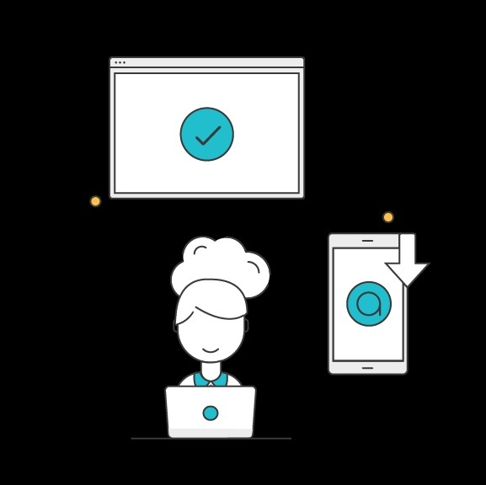

BRAILLE IS BEAUTIFUL

Na na na-na na na, na na na-na nah.
Na na na na nah, na na na-na nah.

Chorus:
Go on and live your life,
Don't need a bit of sight.
In the end you'll find
Braille is beautiful.
Put your fingers on the page.
Tell your friends it's all the rage.
It's all gonna be OK, yeah
Braille is beautiful!

Na na na na na na, Na na na-na nah Braille is beautiful!
Na na na-na nah, Na na na-na nah.

Verse
Louis Braille was his name. Slate 'n' stylus was his game.
They tried to stop him, but we adopted the code that paved the way.

Chorus

Na na na na na na, Na na na-na nah Braille is beautiful!
Na na na-na nah, Na na na-na nah.
Na na na-na nah, Na na na-na nah.

BRAILLE IS BEAUTIFUL!

2019 NFBMD EXHIBITORS
The following is a list of organizations that will be participating in the 2019 NFBMD Exhibit Hall. Check NFBMD.org for updates and additions to this list.

- Vanda Pharmaceuticals
- Election Systems & Software (ES&S)
- Maryland State Library for the Blind and Physically Handicapped
- Maryland Technology Assistance Program
- Sprint Accessibility
- Visit Baltimore
- Aira
- AT Guys
- Bureau of Engraving and Printing
- Centers for Medicare & Medicaid Services (CMS)
- Dave Steele, the Blind Poet
- Envision Technology
- Integration Technologies Group
- JW.org
- Low Vision Specialists of Maryland and Virginia
- Maryland ABLE
- Maryland Department of Disabilities, Assistive Technology Program
- Maryland Division of Rehabilitation Services (DORS)
- Maryland Relay / Telecommunications Access of MD
- NFBMD National Harbor Chapter
- NFBMD Seniors Division
- National Security Agency (NSA)

- Paparazzi Accessories (jewelry)
- Rare Patient Voice
- Sheria Young
- Sound Pro
- The Image Center of Maryland

