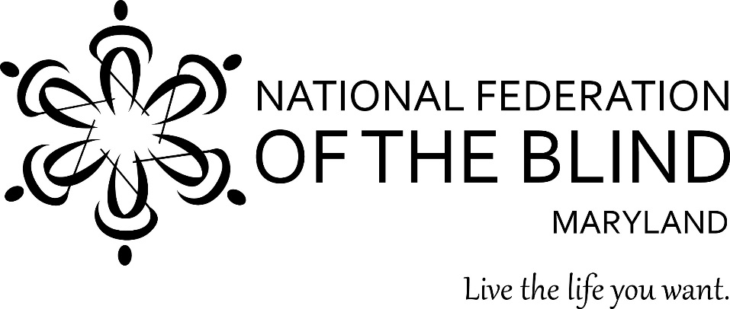

________________________________________________________________________

National Federation of the Blind Center of Excellence in
Nonvisual Access to Education, Public Information, and Commerce

The State of Maryland, through the Maryland Department of Disabilities (MDOD), has supported the National Federation of the Blind (NFB) Non-Visual Accessibility Initiative (NVAI) under the NFB Center of Excellence in Nonvisual Access (CENA) to Education, Public Information, and Commerce. Maryland funds have facilitated the initial establishment of a robust suite of activities that continues to evolve, and has already begun to raise awareness of nonvisual accessibility. We have hosted two Web Accessibility Training Day seminars, providing private companies, government entities, educational institutions, and other interested parties in Maryland the tools they need to make their services and information available to all Americans. These seminars have been recognized as the premier gathering of nonvisual accessibility professionals in the region. Additionally, we have begun hosting accessibility boutiques, lunch-and-learn seminars that offer education on specific accessibility topics. Moreover, we have established an NVAI research and development working group that brings together key players in information technology and accessibility from area universities, government agencies, and corporate entities, who work collaboratively to promote the advancement of nonvisual accessibility throughout the state. This group has reviewed a soon-to-be distributed accessibility needs survey developed by CENA personnel. Additionally, work has begun on the formation of an accessible academic ebook collection, making more than ten million digital books available to blind Marylanders via access to the Hathi Trust collection. The following outlines key areas for development, should funding continue.

Education
Online Infographics Repository: Images, diagrams, charts, etc. collectively known as infographics make up a significant and essential part of the information presented in digitally published materials, in print books, in learning materials, and on the web. Substantial advances have been made to facilitate the nonvisual accessibility of these images for the blind, but now work must be done to share accessible infographics and files for producing 3D tactile models in order to expand access, reduce the duplication of effort, and create new practices in the field.

Public Information
Nonvisual Wayfinding Technologies: Emerging nonvisual access navigation technologies offer orientation and information solutions to a variety of public and commercial venues, including public transportation information. These technologies, in addition to assisting the state of Maryland meet current ADA requirements, provide greater access for sighted citizens as well. As Maryland reinvests in its public transport system and upgrades its public spaces to incorporate new technologies, the time is right to ensure nonvisual access and provide additional opportunities to its diverse populace.

Commerce
Online Accessible Compliance Information Portal: An online portal that centralizes best practices and available resources for effectively building websites to comply with world standards established by the World Wide Web Consortium (W3C), including the Web Content Accessibility Guidelines (WCAG), and the purchase of accessible technologies. This portal would provide information specific to corporate entities, as well as schools and institutions of higher education that would enable them to be in compliance with state and federal law.

