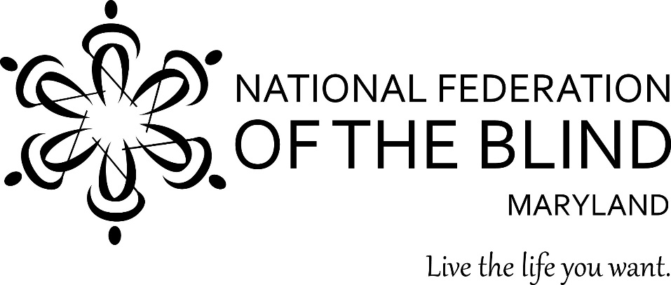

To: Members of the Maryland General Assembly
From: Members of the National Federation of the Blind of Maryland
Contact: Sharon Maneki, President
National Federation of the Blind of Maryland
9013 Nelson Way
Columbia, MD 21045
Phone: 410-715-9596
Email: nfbmd@earthlink.net

Subject: Strengthening Nonvisual Access Procurement Requirements
Date: January 19, 2017

THE PROBLEM
Maryland has excellent laws that require state government agencies to make information and communication technology (ICT) and technology services, such as websites, accessible to the blind. Unfortunately, these laws are poorly enforced and sometimes ignored all together. Consequently, blind citizens are denied access to information that is available to the rest of the public. Blind employees are often ineffective at their jobs because they do not have nonvisually accessible tools to do their work.

PROPOSED ACTION
In 1998 and 2000, legislation was enacted that incorporated nonvisual access requirements into the procurement process. The Maryland General Assembly should now strengthen these laws by assigning responsibility for their enforcement to an Access Technology Officer; by establishing penalties for noncompliance by vendors; and by updating the 2000 law to reflect changes in current technology.

BACKGROUND
Blind people can use special screen reading devices that enable them to read data and fill out forms by using synthetic speech or Braille output devices. These screen reading devices will work only if the websites, document formats, or other hardware and software are designed to accommodate nonvisual access. The methods for nonvisual access are well known and well documented. The first publicly available accessibility guidelines were published in 1995 and have been updated periodically. Yet, the problem of nonvisual access remains unresolved.
The executive branch of Maryland state government continues to discriminate against blind citizens by denying us access to public information and services. This discrimination persists even though there are specific state and federal laws requiring access for all citizens. These laws have been in effect for decades.
When the state of Maryland solicits bids from vendors, it requires the products in question to include nonvisual access. The concept used in state and federal laws of placing nonvisual access requirements in the procurement process is a good one. It is cost effective for the vendor to incorporate nonvisual access during the design phase of the product rather than having to go back later and redesign the product. Why does this problem remain?
- Maryland state government lacks a centralized authority to determine whether products really meet nonvisual access requirements.

Frequently, vendors just have to check the box on a proposed contract stating that its product is accessible. The state agency or department purchasing the product assumes that the vendor is correct, but has no way of checking the validity of the vendor’s claim. The procurement law should be strengthened by establishing a Chief Access Technology Officer (CATO) with the authority to review and evaluate all products before they are purchased. It is crucial that the CATO has sufficient authority and resources, because frequently the state of Maryland has ignored advice from the Department of Disabilities or other advisors attesting to the nonaccessiblity of a particular proposed product for purchase.

- The present procurement law includes no consequences for vendor’s failure to provide nonvisual access.

Currently, vendors have no incentive to comply with procurement accessibility requirements. Strengthening the procurement law by providing for vendor penalties will demonstrate the importance of the requirement to the vendor. Reasonable penalties such as the following will not have a detrimental impact on the vendor but will achieve the goal of nonvisual access.

- Requiring that all state contracts with vendors shall include a provision that, upon a determination within eighteen months from procurement or latest upgrade, if any access barriers are present, the CATO shall notify the vendor of such access barriers, and the vendor shall be required to remediate those barriers.
- Requiring the CATO to notify the vendor of the access barrier in writing at the vendor’s place of business and require the vendor, at the vendor's own expense, to remedy the defect. Should the vendor fail to remediate the access barrier within twelve months from the date of notice, a civil penalty shall be applied at the rate of 1% of the total purchase price of the contract for each day until the problem is remediated, or until the full price of the contract is refunded.
Vendors should not object because they have a year to fix the problem before any penalty is invoked. Placing a cap on the penalty which is the price of the contract, is fair to the vendor while helping the state to recoup its losses.
- The procurement law needs to be updated to accommodate technology changes.

Technology has improved and changed dramatically since the nonvisual access requirements in the procurement law was enacted in 2000. During these seventeen years, technologies have become more powerful and cheaper. For example, instead of buying a desktop system for thousands of dollars, customers can purchase an iPad Pro for $600. Currently, the procurement law allows a vendor to ask for an exemption to the nonvisual access requirement if adding the accessibility features would cost an additional 5%. Since it is cheaper to produce technology, the cost this exemption is too low. Raising the exemption to 15% would be a more reasonable reflection of the actual accessibility cost, and it is still fair to the vendor. Raising the exemption to 15% will close the flood gates that currently permit vendors to opt out of accessibility requirements.

The state of Maryland adopted the federal government’s section 508 nonvisual accessibility standards as its standards of operation. Since the federal government has recently updated these standards, the state of Maryland should adopt the same updates by January 1, 2018. This is a reasonable timeline because the standards already exist.

CONCLUSION
Nonvisual access to public information provided by the state of Maryland should be improving because the knowledge and tools now exist to provide greater access. According to state and federal laws, Maryland is not supposed to purchase information and communication technology products or services that are not accessible to the blind. Blind citizens do not currently have the same access to information as the rest of the general public, because Maryland does not enforce its laws. Maryland should be a model employer of persons with disabilities. However, Maryland ignores the accessibility laws and blind workers do not have the tools to perform their jobs efficiently. It is time to strengthen the procurement law so that nonvisual access becomes a reality.

