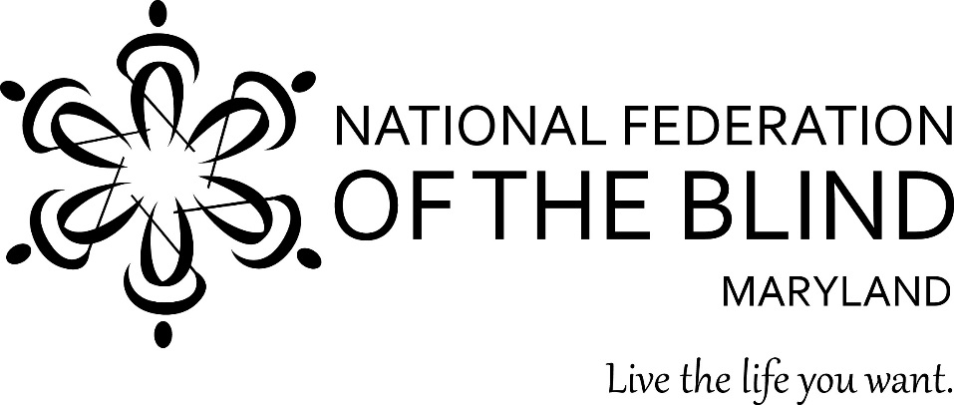

Subject: Nonvisual Access to Information Concerning Dockless Electric Scooters (E-scooters)
To: Members of the Maryland General Assembly
From: Members of the National Federation of the Blind of Maryland
Contact: Sharon Maneki, Director of Legislation and Advocacy
National Federation of the Blind of Maryland
9013 Nelson Way
Columbia, MD 21045
Phone: 410-715-9596
Email: nfbmd@earthlink.net
Date: January 16, 2020
THE PROBLEM
Maryland law provides the following definition: “’Electric low speed scooters’ means a vehicle that: is designed to transport only the operator, weighs less than 100 pounds, has single wheels in tandem or a combination of one or two wheels at the front and rear of the vehicle, is equipped with handlebars and a platform designed to be stood on while riding, is solely powered by an electric motor and human power, and is capable of operating at a speed of up to 20 miles per hour.”
These devices are generally rented through a website or mobile application, are picked up and dropped off in the public right-of-way and are meant for short point-to-point trips. E-scooters are a popular form of transportation in Maryland and throughout the nation. The general public rents such devices from e-scooter companies. E-scooter riders frequently create barriers to pedestrian movement. Blind pedestrians need the same access to information about these scooters that sighted pedestrians have in order to inform e-scooter companies of obstacles created by their vehicles.
PROPOSED ACTION
The Maryland General Assembly should enact legislation requiring e-scooter companies to provide the blind pedestrians access to the same information as they provide to the sighted public. These companies must provide nonvisual access to information on their websites and phone apps so that the blind can inform such companies of obstacles and barriers caused by their own e-scooters. Companies must also provide a tactile indicator on every e-scooter so that blind pedestrians can identify and contact the owners of offending devices.
BACKGROUND
Dockless e-scooters are proliferating in the streets and roads of Maryland and the nation. E-scooters, while inexpensive and environmentally friendly, pose challenges to pedestrians due to rider behavior. E-Scooter riders operate these vehicles on sidewalks, often weaving in and out of pedestrian traffic. This causes all pedestrians, especially the elderly, children, those with mobility challenges, and the blind, to have to swerve quickly and walk defensively to avoid getting hurt. The laws prohibiting persons from riding e-scooters on sidewalks are poorly enforced.
Once riders finished with the ride, they may leave the e-scooter virtually anywhere. Once again, this creates a hazard for all pedestrians, particularly the elderly, children, individuals with mobility challenges, and the blind. E-scooters further impede pedestrian access because riders often leave them at or near curb cuts, in front of stoops and entrances to private homes and businesses, in front of bus stops and other public transportation hubs, near tree wells which narrow the sidewalks, or in the middle of sidewalks so that no one can get around them without having to walk into the adjacent street.
In order to notify e-scooter companies of the inappropriate placement or usage of e-scooters, users and the public are instructed to contact the appropriate company authorities, provide the offending device identification number, and make a report via that company’s telephone number, website, or smart phone application. In certain localities, individuals may need to contact local law enforcement about a particular device and provide it with device identifying information. However, if these devices do not have a nonvisual means of identifying their manufacturer, operating company contact information, or identification number, blind pedestrians are denied the ability to make such reports. E-scooter websites and apps are also frequently inaccessible, which further precludes the blind from being able to report misuse of e-scooters.
ADVANTAGES OF THE PROPOSED LEGISLATION
Providing tactile identifying information on any e-scooter will benefit all pedestrians, including the blind. Providing such information is a good business practice and is not a financial burden to e-scooter companies.
Requiring company apps and websites to be nonvisually accessible makes the websites and apps easier to use for all. Maintaining nonvisual access is crucial and cost effective. Doing it right from the beginning and keeping it right avoids costly future retrofitting of websites and apps.
CONCLUSION
If sighted pedestrians have access to information so that they can contact companies regarding problems with dockless e-scooters, blind pedestrians are entitled to the same information. Members of the National Federation of the Blind of Maryland urge the Maryland General Assembly to enact legislation requiring dockless e-scooter companies to provide nonvisual access to identifying information on all e-scooters as well as access to its websites and phone apps. This legislation must ensure that all members of the public, including the blind, have equal access to information in order to communicate with company officials and law enforcement authorities. With these provisions in place, all members of society can come to appreciate the benefits of dockless e-scooters.

