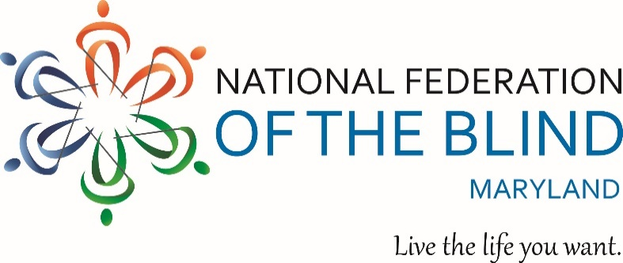
9 ^{TH} Annual County Resource Day for
Blind & Low Vision Persons
Sponsored by: The National Harbor Chapter, National
Federation of the Blind of Maryland
Theme: UPLIFT!
Date: October 12, 2019
Time: 10 a.m. to 2 p.m.
Where: Colmar Manor Community Center and Town Hall
3701 Lawrence Street
Colmar Manor, MD 20722
*In Brentwood, just outside of the D.C. Line from Bladensburg Road, North East
Learn about assistive technology, housing assistance, health & wellness, financial stability, rehabilitation, and more!
Admission: FREE, but all attendees must pre-register. You can register two ways:
1) Online at brownpapertickets.com/event/4356918
2) Telephone at 1-800-838-3006
The event also is a donation location for the Annual Hygiene Kit Project benefiting persons experiencing homelessness.
For more information, contact Chairperson Amber Woods at woodsamber83@gmail.com or 301-978-6686.

