Autumn Walk in the Park!


The Greater Baltimore Chapter is participating in the Coast-to-Coast Movement Challenge in support of the National Federation of the Blind.

Where? Riverside Park
When? Saturday, November 7, 2026, 10AM-2PM


WALK with us, SPONSOR a walker, or stop by to LEARN more about the NFB while enjoying a sweet treat from our BAKE SALE.

Your contributions will help:
- Send free white canes to give independence
- Increase Braille literacy to give the gift of reading
- Teach STEM to blind youth
- Advocate for blind children in schools, blind adults at work, and more.

Ways to donate:
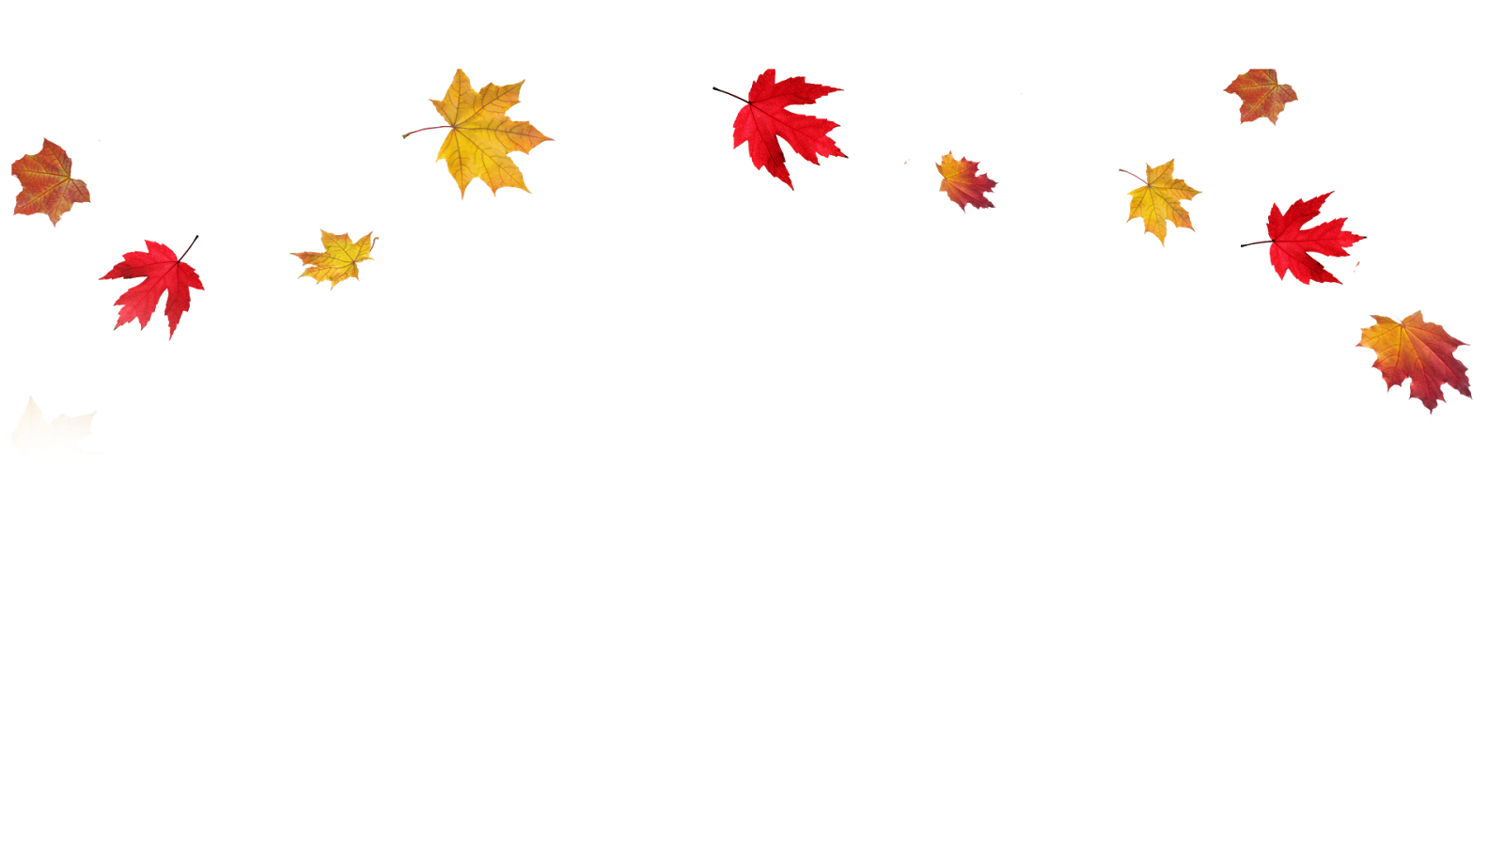
- Call 410-659-9314, extension 2430 to give over the phone. Make sure to mention the Greater Baltimore Chapter and the Coast-to-Coast Movement Challenge.
- Scan the QR code below to make a secure online contribution. Include Greater Baltimore Chapter in the “in honor of” field! Sponsor a walker by including their email so they receive a notification of your support.
- And thanks to HumanWare contributions are doubled up to $50,000.


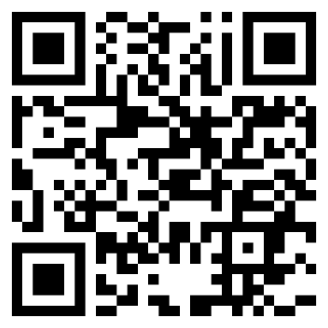
Thank you for your support!

