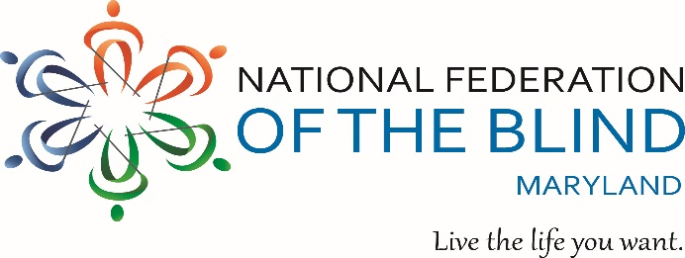
ANNUAL CRAB FEAST
To benefit the John T. McCraw Scholarship Fund
Friday, September 18, 2026 - 7:00 p.m. to 11:00 p.m.
Rosedale Gardens – 8037 Philadelphia Road - Baltimore, MD 21237
Steamed Crabs, Fried Chicken, Beef Bar-B-Que – All You Can Eat!
Plus a Buffet of Entrees Including Maryland-style crab soup, corn-on-the-cob, other Sides, Salads, fruit, Cake…
Yuengling and Miller beer
Carbonated Beverages, Coffee, and Tea


Tickets: $85.00 per person if purchased on or before 8/31/26 OR $95.00 per person if purchased after 8/31/26. Children 6 and under are FREE.
Bringing a Group? Purchase a table that seats 10 people for $850.00.

Purchaser’s Name: ____________________________________________________

Address: ____________________________________________________________

City: ___________________________ State: ____________ Zip: _____________

Phone: ( ) ________________ Email: ________________________________

Number of Tickets Needed: _______ @ $85.00 each OR ______ @ $95.00 each

Amount Due: $_________________ Tickets Sold By: ______________________

Buy or Sell 25 or more tickets and your ticket is FREE!
If you cannot attend, donations are always welcome!
Three ways to pay or donate:
Credit card or PayPal: Https://nfbmd.org/crabs
Zelle: Payments@nfbdmd.org
Check: (payable to NFBMD) NFBMD Crab Feast, 1800 Johnson Street, Suite N1, Baltimore, MD 21230
For additional information: Call (202) 494-5687 or email TLCchapter@nfbmd.org

