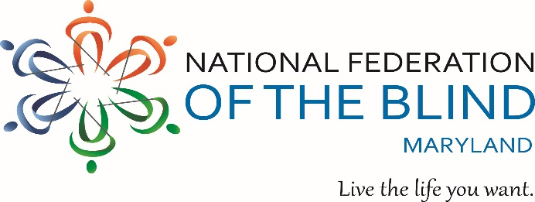

Dear Friend,

On behalf of the National Federation of the Blind of Maryland (NFBMD), we invite you to partner with us by sponsoring our Annual NFBMD Crab Feast, taking place Friday, September 18, 2026, from 7:00 p.m. to 11:00 p.m. at Rosedale Gardens in Baltimore. This cherished community event raises essential funds for the John T. McCraw Scholarship Program, one of Maryland’s most impactful initiatives supporting blind students.

The John T. McCraw Scholarship Program honors the legacy of longtime Federationist and advocate John T. McCraw, who dedicated his life to expanding educational opportunities for blind Marylanders. Each year, the program provides financial assistance to blind students pursuing post-secondary education at accredited colleges, universities, and vocational or trade programs. Scholarships are awarded based on academic achievement, leadership, community involvement, and a demonstrated commitment to living the lives they want.

In 2026, NFBMD will award five scholarships, expanding our ability to support promising blind scholars across the state. Your sponsorship directly fuels these awards, helping students cover tuition, technology, books, housing, and other essential educational expenses.

The Crab Feast brings together hundreds of blind Marylanders, families, friends, and supporters for an evening of food, fellowship, and purpose. As a sponsor, you will have a unique opportunity to connect with attendees, promote your organization, and make a tangible difference in the lives of blind students.

Your sponsorship does more than sustain the event itself. It strengthens our year-round work to expand educational access, increase employment opportunities, challenge misconceptions about blindness, and promote independence for blind Marylanders of all ages.

We invite you to review the 2026 Crab Feast Sponsorship Opportunities below and join us in empowering the next generation of blind scholars.

If you have questions, please contact us at (202) 494-5687 or TLCchapter@nfbmd.org. With

Overwhelming Gratitude,
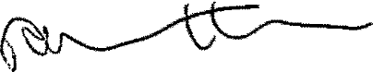
Ronza Othman, President
National Federation of the Blind of Maryland

National Federation of the Blind of Maryland
2026 Crab Feast

Supporting the 2026 John T. McCraw Scholarship Fund
September 18, 2026

Rosedale Gardens
8037 Philadelphia Road Baltimore, MD 21237

Sponsorship Opportunities

Doctoral Sponsor — $5,000
- Full reserved table (10 seats)
- Recognition during event program
- Logo featured on event signage
- Promotion on NFBMD social media
- Acknowledgment on https://nfbmd.org
- Opportunity to provide branded materials for attendees
Master’s Sponsor — $3,500
- Four reserved seats
- Recognition during event program
- Promotion on NFBMD social media
- Acknowledgment on https://nfbmd.org
Bachelor’s Sponsor — $2,500
- Recognition during event program
- Acknowledgment on https://nfbmd.org
- Promotion on NFBMD social media
Associate Sponsor — $1,000
- Recognition during event program
- Acknowledgment on https://nfbmd.org
Table Level Sponsor — $850
- A table for 10 people reserved for you.

We welcome donations of door prizes valued at $25 or more (cash, gift cards, tickets, or company items). Please send donations by September 1, 2026 to:
National Federation of the Blind of Maryland 1800 Johnson Street
Suite N1
Baltimore, MD 21230
Be sure to include the name of your organization so that we can provide appropriate acknowledgment during the Event.

National Federation of the Blind of Maryland
2026 Crab Feast Sponsor Registration Form

Sponsorship Level (please check one)

_____ | Doctoral Sponsor ($5,000)
_____ | Master’s Sponsor ($3,500)
_____ | Bachelor’s Sponsor ($2,500)
_____ | Associate Sponsor ($1,000)
_____ | Table Sponsor ($850)

Organization
Name:
Address:
City, State & Zip:
Web Address:
Contact Person
Name:
Telephone:
Email address:
If also donating a Door Prize, please indicate what item(s):

Please complete your sponsorship by June 30, 2026

Electronically – Please email this form to TLCchapter@nfbmd.org and make your payment via one of the below methods:
- Zelle: Payments@nfbmd.org – Please include a memo stating “Crab Feast Sponsorship”
- Credit Card or PayPal: Visit https://nfbmd.org/crabs. Please note that credit card and PayPal payments require a $3 processing fee per ticket.

By Mail – Please send this form along with your check:
- Payable to: NFB of Maryland with Memo Crab Feast Sponsorship
  - Mail to: National Federation of the Blind of Maryland
    - 1800 Johnson Street, Suite N1, Baltimore, MD 21230

