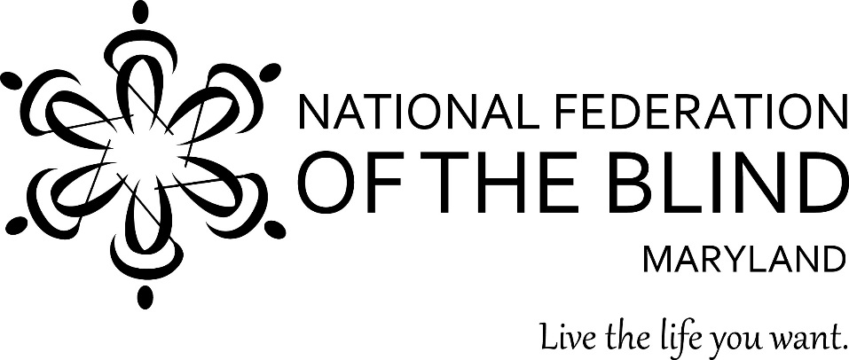

To: Members of the Maryland General Assembly

From: Members of the National Federation of the Blind of Maryland

Contact: Sharon Maneki, President
National Federation of the Blind of Maryland
9013 Nelson Way
Columbia, MD 21045
Phone: 410-715-9596
Email: nfbmd@earthlink.net

Subject: Appropriation for the Center of Excellence in Nonvisual Access (CENA) to Education, Public Information, and Commerce
Date: January 19, 2017

PROPOSED ACTION

The Maryland General Assembly should keep the $250,000 appropriation in the Governor’s Budget for the CENA to Education, Public Information, and Commerce.

BACKGROUND

In 2014, the National Federation of the Blind (NFB) founded the NFB CENA. The CENA is a center of expertise, best practices, and resources that enables business, government, as well as educational institutions to more effectively provide accessible information and services to blind citizens. The State of Maryland, through the Maryland Department of Disabilities (MDOD), has an ongoing partnership with the CENA to support a series of projects collectively referred to as the Nonvisual Accessibility Initiative (NVAI) with an aim to establish Maryland as a leader in nonvisual accessibility.

PROPOSED PROJECTS FOR FISCAL YEAR 2017-2018

Accessible Academic E-Book Program
The HathiTrust is a consortium of institutions offering a collection of more than 10 million titles digitized from around the world, including textbooks. The NFB is working with the HathiTrust to make these books available to all blind and print-disabled persons, regardless of institutional affiliation. The project is a unique opportunity to create a nationwide accessible library for people with disabilities to obtain the materials they need, with the immediacy that they need it.

Accessibility Boutiques and Training Seminars
The CENA, with financial support from the NVAI, has produced a number of informal accessibility-specific boutiques and training seminars. The boutiques offered by the CENA have been hosted at the NFB Jernigan Institute, are several hours long, and are open to the public at no cost to Maryland citizens. Additionally, the NFB has produced several larger training seminars with support from MDOD and the NVAI grant. Training seminars are more intensive and take place over an entire day or several days. In 2017-18, the CENA will produce additional boutiques and training seminars, and will reach more participants in areas across the state.

Accessibility Switchboard
The Accessibility Switchboard is an online accessibility portal that will provide up-to-date information to consumers about accessible websites, emerging technology, as well as frequently encountered accessibility problems and solutions. It will be a point of contact for consumers who wish to voice concerns about barriers to nonvisual access, so that the CENA can evaluate and address these concerns. Moreover, it will provide information specific to government, corporate, and educational institutions on effectively building websites that comply with web standards, and information on the procurement of accessible technologies.

WayFinding Technology
Emerging nonvisual access navigation, or wayfinding technology, offers orientation and information solutions to a variety of public and commercial venues, including public transportation information. As Maryland reinvests in its public transport system through the Baltimore Link initiative, and upgrades its public spaces to incorporate new technologies, the time is right to ensure nonvisual access and provide additional access opportunities to its diverse populace by implementing the use of nonvisual wayfinding technologies to assist and provide greater access for citizens with disabilities and nondisabled citizens as well.

CONCLUSION

Access to information remains one of the greatest barriers faced by blind persons. To reduce these barriers the National Federation of the Blind established the CENA to provide information about best practices and to develop innovative techniques for achieving nonvisual access. The Maryland General Assembly should allow this state-of-the-art program to continue by approving the $250,000 appropriation in the Governor’s Budget under the Maryland Department of Disabilities.

