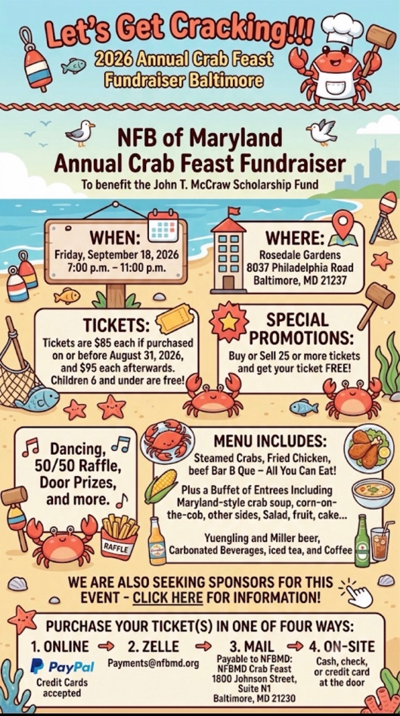

Cartoon-style beach-themed flyer for a crab feast fundraiser with crabs, seashells, food, and text in multiple boxes.

Text reads:

Let’s Get Cracking!!
2026 Annual Crab Feast Fundraiser Baltimore

NFB of Maryland
Annual Crab Feast Fundraiser
To benefit the John T. McCraw Scholarship Fund

WHEN:
Friday, September 18, 2026
7:00 p.m. – 11:00 p.m.

WHERE:
Rosedale Gardens
8037 Philadelphia Road
Baltimore, MD 21237

TICKETS:
Tickets are $85 each if purchased
on or before August 31, 2026,
and $95 each afterwards.
Children 6 and under are free!

SPECIAL PROMOTIONS:
Buy or Sell 25 or more tickets
and get your ticket FREE!

Dancing,
50/50 Raffle,
Door Prizes,
and more.

MENU INCLUDES:
Steamed Crabs, Fried Chicken,
beef Bar B Que – All You Can Eat!

Plus a Buffet of Entrees including
Maryland-style crab soup, corn-on-
the-cob, other sides, Salad, fruit, cake…

Yuengling and Miller beer,
Carbonated Beverages, iced tea, and Coffee

WE ARE ALSO SEEKING SPONSORS FOR THIS
EVENT – CLICK HERE FOR INFORMATION!

PURCHASE YOUR TICKET(S) IN ONE OF FOUR WAYS:

1. ONLINE
PayPal
Credit Cards accepted

2. ZELLE
Payments@nfbmd.org

3. MAIL
Payable to NFBMD:
NFBMD Crab Feast
1800 Johnson Street,
Suite N1
Baltimore, MD 21230

4. ON-SITE
Cash, check,
or credit card
at the door

