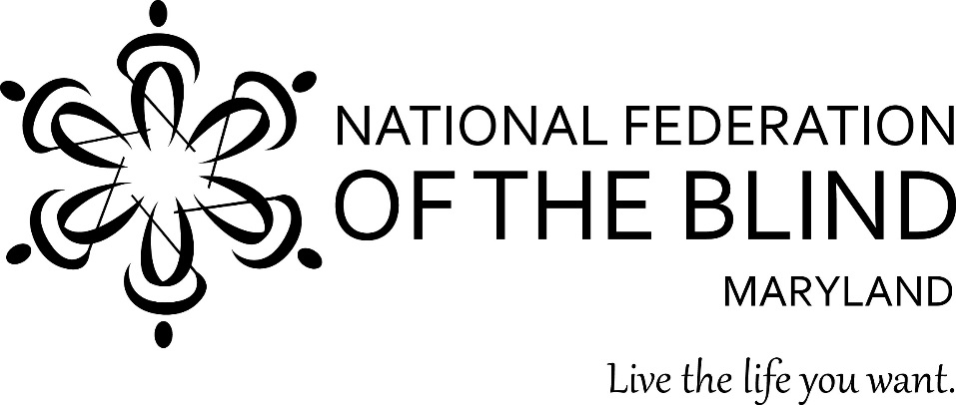

To: Members of the Maryland General Assembly

From: Members of the National Federation of the Blind of Maryland

Contact: Sharon Maneki, President
National Federation of the Blind of Maryland
9013 Nelson Way
Columbia, MD 21045
Phone: 410-715-9596
Email: nfbmd@earthlink.net

Subject: Ken Capone Equal Employment Act

Date: January 21, 2016
________________________________________________________________________

THE PROBLEM
Since 1938, some employers have been legally paying less than the minimum wage to their disabled employees. This exemption from paying the minimum wage was granted in section 14(c) of the Fair Labor Standards Act of 1938. While this exemption may have been necessary in 1938, today it is antiquated, unfair, and discriminatory. With proper training, support, and the expectation of equal work for equal pay, employees with disabilities can be as productive as their nondisabled counterparts, and deserve to be paid at least the state minimum wage.

PROPOSED ACTION
The Maryland General Assembly should enact legislation that amends Article - Labor and Employment, Section 3-414, annotated code of Maryland, to prohibit the Commissioner of Labor and Industry from authorizing work activities centers or sheltered workshops from paying disabled employees less than the minimum wage. To achieve this goal, the legislation must instruct the Commissioner of the Division of Labor and Industry in the Department of Labor, Licensing, and Regulation (Commissioner) to immediately stop approving new Maryland 14(c) certificates. Any entity that already has a certificate shall immediately cease adding new employees to the list of individuals who are paid subminimum wages. By January 1, 2019, entities that pay workers with disabilities subminimum wages shall be prohibited from obtaining State funds. The goal of this legislation is to eliminate all 14(c) certificates in Maryland.

BACKGROUND
Many Maryland sheltered workshops and nonprofit entities use the exemption granted in section 14(c) of the Federal Fair Labor Standards Act to pay workers with disabilities less than the minimum wage. The original intent, when this exemption was created in 1938, was to incentivize for-profit businesses to hire people with disabilities. However, section 14(c) has failed to achieve this outcome. A 2001 U.S. Government Accountability Office (GAO) study found that less than 5% of the workers who were paid less than the minimum wage transitioned into competitive integrated employment.

According to data collected by Maryland Works, Inc., a statewide membership association that expands employment and business ownership opportunities for people with disabilities, there are currently 3,200 Maryland residents with disabilities who are paid subminimum wages. These workers are employed by 40 nonprofit organizations. In 2015, twenty percent of individuals with developmental disabilities in Maryland worked in facility-based settings where they were paid an average of merely $3.88 per hour. Paying workers less than half the minimum wage condemns them to a life of poverty and dependency on government benefits.

Paying subminimum wages to workers with disabilities is outdated and unnecessary. Since 1938, technological advancements, innovative employment strategies, and society’s increased progressive views toward individuals with disabilities have increased opportunities for employment for individuals with disabilities. Disabled employees, their families and employers have gradually acquired higher expectations for individuals with disabilities. We do not view ourselves as imperfect people who need to be pitied, and every year, more people without disabilities are viewing people with disabilities in this light as well. We are excellent employees who, with the proper training, support, and expectations, can perform jobs as well as, or better than, people without disabilities. Consequently, workers with disabilities deserve to be paid the same amount as their colleagues without disabilities.

Today, disabled employees who earn less than the minimum wage are merely placed in the wrong jobs and not working to their full potential. For example, if Kayla is blind and working at a department store at a subminimum wage, her job should not be sorting stuffed animals by color or sorting clothing by size, because these tasks inherently require sight. Instead, she could be more productive and earning a minimum wage if her job were to arrange clothes on hangers or to fold them neatly. Kayla could be most productive if she were trained to provide customer service and given reasonable accommodations to render those tasks efficiently. Customizing employment with reasonable accommodations is a more successful approach to productive employment than the outdated sheltered workshop business model of providing the least skilled jobs to disabled persons. It is time for Maryland to modernize its practices and policies to provide equal employment opportunities for people with disabilities.

In recognition of the growing demand for equal employment at the federal and state levels, advocacy groups in Maryland began to plan for needed reforms. In 2014, legislation to raise the minimum wage adopted by the Maryland General Assembly and signed by Governor O’Malley did not include workers with disabilities. This failure increased the sense of urgency in the disability community to eliminate all 14(c) certificates in Maryland. The Equal Employment Coalition, under the leadership of People on the Go, a Maryland advocacy organization who strives to eliminate discrimination for individuals with intellectual and developmental disabilities, was established to correct the oversight of the 2014 law.

Coalition members include:
APSE Maryland,
Arc of Maryland,
Autistic Self Advocacy Network,
Blind Industries and Services of Maryland,
Maryland Association of Community Services,
Maryland Disability Law Center,
The Image Center for People with Disabilities,
Maryland Works,
Melwood,
National Federation of the Blind of Maryland,
People on the Go.

The legislation recommended in this document is the result of the efforts of this coalition. It is named after Ken Capone, Public Policy Coordinator, for People on the Go, because he demonstrates what people with disabilities can accomplish when they are presented with opportunities and support. Mr. Capone escaped the sheltered workshop system despite his multiple disabilities through sheer determination. This legislation is consistent with legislation currently being pursued in Congress by the National Federation of the Blind which seeks the elimination of all 14(c) certificates. The bills in Congress are HR188 and S2001.

REASONABLE LEGISLATION
The proposed legislation gives employers three years to eliminate the practice of paying current disabled employees subminimum wages by developing better business practices. This grace period also permits rehabilitation service providers sufficient time to improve the quality of training for their clients and to place more of them in competitive integrated employment. By definition, competitive integrated employment pays at least the minimum wage.
To foster smooth implementation, the legislation instructs the Department of Labor, Licensing, and Regulation to partner with relevant state agencies, advocacy groups, service providers, families, and other stakeholders to develop an implementation plan. The plan shall include the identification of resources to ensure that disabled workers receive all of the necessary supports that they need. The plan must include benchmarks and outcomes for each year of the certificate phase-out such as the tracking of unemployment rates and the number of disabled workers who move from subminimum wage positions to competitive, integrated employment or non-paying activities. The Department must also provide an annual report to the General Assembly which will allow legislators and the public to assess the progress toward equal employment.

BETTER USE OF TAX DOLLARS
The proposed legislation will lead to a better use of Medicaid and vocational rehabilitation funds. The substantial amount of money taxpayers invest in vocational rehabilitation programs is meant to provide job training for persons with disabilities. In a collaborative study by Kent State University and Virginia Commonwealth University, researchers examined whether sheltered workshops prepare employees with autism spectrum disorder for work in the community. In this study, published in 2012, individuals with disabilities in subminimum wage environments worked fewer hours, made less money, and cost more money to employ than their counterparts in integrated settings. Instead of supporting subminimum wage employment, this study strongly boosts the argument that Medicaid and vocational rehabilitation funds could be put to better use to help disabled workers to obtain competitive integrated employment. From an economic standpoint, businesses who use a supported employment or a customized work model, paying minimum wages will offer more work experience for less cost.

A GROWING TREND
The civil rights movement throughout the disability community has been calling for more integration into mainstream society for many years. For example, the Americans with Disabilities Act, enacted in 1990, requires public agencies to provide services "in the most integrated setting appropriate to the needs of qualified individuals with disabilities." This principle was further affirmed by the Supreme Court in its 1999 Olmstead decision. Another important step towards integration into society, and more specifically the goal of integrated employment, was accomplished when the National Federation of the Blind and other advocacy groups convinced President Obama to include workers with disabilities in his executive order that raised the minimum wage for federal contract workers. Executive Order 13658, signed on February 12, 2014, reads in part that federal agencies “must ensure that new contracts include a clause, specifying that the minimum wage to be paid to workers, including workers whose wages are calculated pursuant to special certificates issued under [Section 14(c)], in the performance of the contract or any subcontract thereunder, shall be at least $10.10 per hour beginning January 1, 2015.” Advocacy organizations were able to convince Congress to continue this trend with the enactment of the Workforce Innovation and Opportunities Act in July, 2014. Section 511 of this law prohibits youths with disabilities from being compensated at subminimum wages by section 14(c) certificate holding entities, unless they first have exhausted all resources available to them through vocational rehabilitation services. This law will increase the chances that young people will never enter the sheltered workshop system and experience the degradation of making less than the minimum wage.

Some states are also following this trend. Vermont and New Hampshire no longer have any subminimum wage sheltered workshops. Vermont gradually phased out funding for sheltered workshops, just as the proposed Ken Capone Equal Employment Act will do. Last year, New Hampshire passed legislation prohibiting employers from paying workers with disabilities subminimum wages.

Several nonprofit companies in Maryland have already helped individuals with disabilities find competitive employment. For example, in 2014 Cari DeSantis, the CEO of Melwood, a Maryland nonprofit which employs over 700 individuals with disabilities, pledged to pay all of Melwood’s employees at least the minimum wage. Since that time, she has further promised to pay at least $10.10 per hour.

Penn-Mar Human Services, a nonprofit that provides support services to individuals with disabilities, also eliminated the practice of paying disabled employees less than the minimum wage in 2015.

Blind Industries and Services of Maryland has been paying its disabled employees at least the minimum wage or better for forty years. It is time for all forty nonprofit entities in Maryland to pay disabled workers the minimum wage.

CONCLUSION
In order for Maryland residents with disabilities to live the lives they want, they must have opportunities for competitive, integrated employment. No one can live on a subminimum wage, especially a person with a disability. Maryland should be a leader in ensuring that people with disabilities have access to the training, support, and expectations they need in order to be employed. Please pass legislation that will make it illegal for people with disabilities to be paid subminimum wages; we deserve equal employment.

Government Accountability Office. “Centers Offer Employment and Support Services to Workers With Disabilities, But Labor Should Improve Oversight” Report to Congressional Requesters. 01-886 (2001): 4.
Department of Labor Wage and Hour Division. “Community Rehabilitation Programs (CRPs) List.” Last modified October 1, 2015. http://www.dol.gov/whd/specialemployment/CRPlist.htm.
Cimera, Robert E.; Wehman, Paul; West, Michael; & Burgess, Sloane. “Do Sheltered Workshops Enhance Employment Outcomes for Adults with Autism Spectrum Disorder?” Autism. 16 (2012): 87.
Melwood. “Cari DeSantis: Fair Pay for Workers with Disabilities.” Last modified February 28, 2014. https://www.melwood.org/news/cari-desantis-fair-pay-for-workers-with-disabilities.

