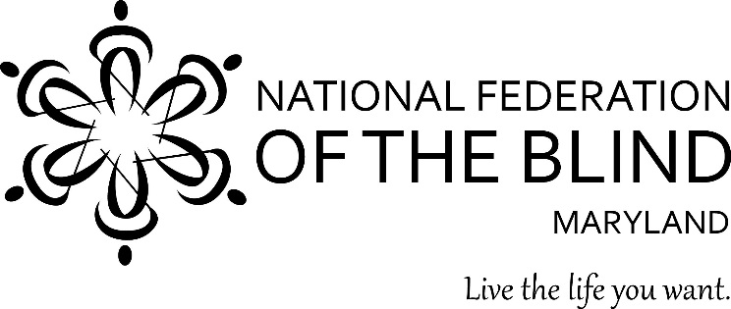 Sharon Maneki, President

Dear Friend:

On behalf of the National Federation of the Blind of Maryland (NFBMD), we invite you to partner with us. By serving as a sponsor or exhibitor for our 52nd NFB of Maryland annual convention, being held November 9-11 in Ocean City, you will be creating opportunities for the blind of Maryland to live the lives we want. It is also an opportunity for you to access a unique customer base while promoting your establishment as a socially responsible organization.

The NFB of Maryland convention attracts approximately four hundred blind individuals, our families, friends, and blindness professionals. As a sponsor and exhibitor, it is an unparalleled opportunity to reach out to blind individuals, highlight your products and services, and support the programs of the NFB of Maryland. Our convention is the place to be this November; you will not want to miss out!

The funding you provide by serving as a sponsor and exhibitor goes far beyond helping support the important activities of the convention. These resources contribute to our work throughout the year as we implement programs to improve education and employment opportunities, raise awareness, shatter misconceptions, provide resources and advocacy, and promote the independence of the blind in Maryland. Your partnership helps us fulfill our mission to ensure the blind of Maryland achieve complete integration into society on the basis of equality.

Thank you for considering this mutually beneficial opportunity. We look forward to partnering with you. Enclosed please find the sponsor and exhibitor opportunities for our 2018 NFB of Maryland Convention. In addition to these opportunities, we are seeking door prizes (minimum $25.00 value), such as cash, tickets, or company items, to be given away during our convention. If you have any questions, please contact Sharon Maneki at (410) 715-9596, or via email at president@nfbmd.org.

With Overwhelming Gratitude,
Sharon Maneki, President
National Federation of the Blind of Maryland

National Federation of the Blind of Maryland
Annual Convention
Sponsorship Opportunities

When: November 9-11, 2018
Where: Carousel Hotel & Resort
118th Street on the Ocean, 11700 Coastal Highway, Ocean City, MD 21842
(410)-321-7400

Title : $2,500
This sponsorship level is exclusive to the first sponsor to secure this spot.
- An opportunity to address the convention of the NFB of Maryland (more than four hundred members in attendance, plus a live internet audience)
- Full-page ad in the convention agenda
- Promotional announcement played every time someone logs onto the convention stream
- Link to corporate website from www.nfbmd.org
- Promotion in NFBMD social media
- Exposure in the Braille Spectator newsletter (for one year)
- Two exhibit tables
- Opportunity to display corporate materials throughout the convention and/or provide premium items for distribution at registration

Independence: $1,500
- Opportunity to be promoted as a luncheon or seminar sponsor—for example, sponsor of the parents of blind children seminar
- Half-page ad in the convention agenda
- Periodic promotional announcement during the convention stream
- Link to corporate website from www.nfbmd.org
- Promotion in NFBMD social media
- Exposure in the Braille Spectator newsletter (for six months)
- One exhibit table

Equality: $1,000
- Quarter-page ad in the convention agenda
- Link to corporate website from www.nfbmd.org
- Promotion in NFBMD social media
- One exhibit table

Opportunity: $500
- Listing under convention sponsors in the convention agenda
- Acknowledgement of sponsorship at www.nfbmd.org
- One exhibit table

Exhibitor: $200
- One exhibit table

National Federation of the Blind of Maryland
2018 Annual State Convention
Sponsor and Exhibitor Registration Form

Our 2018 Title Sponsor receives two exhibit tables, while all other sponsors receive one exhibit table. You will also receive electric and wireless internet. The exhibit hall will be open on Friday, November 9th, 12pm-6pm, with setup beginning at 11am that day.
THIS REGISTRATION FORM MUST BE RECEIVED BY: October 15, 2018
Please check one of the following levels:
Title Sponsor ($2,500) _______
Independence Sponsor ($1,500) ______
Equality Sponsor ($1,000) _______
Opportunity Sponsor ($500) _______
Exhibitor ($200) ______

Organization: __________________________________________

Address: _________________________ City: _________________

State/Region: _____ ZIP Code: ________ Country: _________

Telephone: ________________ Fax: __________________________

Email: ________________________________

Person(s) Responsible for Exhibit at Convention: ______________________

Person to Receive Letter Confirming Receipt of this Application: ___________________

Product/Service to Be Exhibited: ____________________________________________
______________________________________________________________________

List quantity and total cost for additional tables:

______ Additional tables at $200 each = $ ___________

Please check if you need the following (check all that apply):
______ Electricity
______ Internet

Please send this completed application via email to president@nfbmd.org, and mail your check, made payable to the NFB of Maryland, to:

National Federation of the Blind of Maryland
9013 Nelson Way
Columbia, MD 21045

Enclosed for Sponsorship or Exhibit ………………………………………………$____________

Additional table fee ($200 per table) ………………………………………………$____________

Total enclosed………………………………………..…………..............………….$____________

Check number: _____________ (Made payable to the NFB of Maryland)

Special note: Exhibitor's fee covers only the space provided and does not include convention registration for individuals working as exhibitors. DO NOT include payment for convention registration with the payment made on this form.
Send door prizes by November 1st to 9013 Nelson Way Columbia, MD 21045. Be sure to include company name so that we can acknowledge you when we give away the prize.

