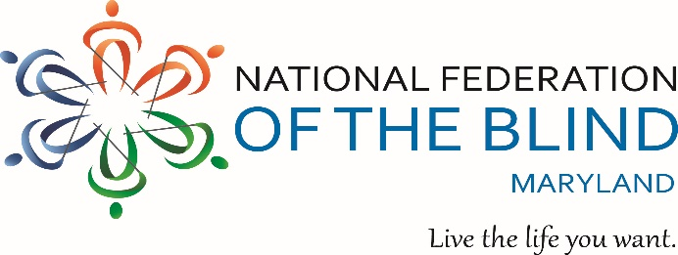

** ANNUAL CRAB FEAST **

To benefit the John T. McCraw Scholarship Fund

**Friday, September 20, 2024 - 7:00 p.m. to 11:00 p.m.**

**Rosedale Gardens –8037 Philadelphia Road- Baltimore, MD 21237**

**Steamed Crabs, Fried Chicken, Beef Bar-B-Que – All You Can Eat!**

Plus a Buffet of Entrees Including Maryland-style crab soup, corn-on-the-cob, other Sides, Salads, fruit, Cake…

Yuengling and Miller beer

Carbonated Beverages, Coffee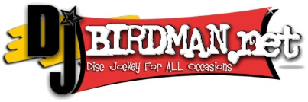, and tea

Music, Dancing, Door Prizes

**Tickets: $75.00** per person if purchased on or **before 8/31/24 OR $85.00** per person if purchased **after 8/31/24**. Children 6 and under are FREE.

Purchaser’s Name: ____________________________________________________

Address: ____________________________________________________________

City: ___________________________ State: ____________ Zip: _____________

Phone: ( ) ________________ Email: ________________________________

Number of Tickets Needed: _______ @ $75.00 each OR ______ @ $85.00 each

Amount Due: $_________________ Tickets Sold By: ______________________

**Buy or Sell 25 or more tickets and your ticket is FREE!**

If you cannot attend, donations are always welcome!

Three ways to pay or donate:

Credit card or PayPal: <Https://nfbmd.org/crabs>

Zelle: [President@nfbmd.org](mailto:President@nfbmd.org)

Check: (payable to NFBMD) NFBMD Crab Feast, 1800 Johnson Street, Suite N1, Baltimore, MD 21230

For additional information: Call (443) 426-4110 or email [President@nfbmd.org](mailto:President@nfbmd.org)